**Name: Period: Seat#:**

**Worksheet #8**

**Directions:**

* Use the following information and the chart to help you walk through the thought process that is needed in order to determine if a salt is acidic, basic, or neutral  
  + - Strong Acid $\underset{→}{turns into a}$ Weak Conjugate Base   
       *(not much effect on pH)*
    - Weak Acid $\underset{→}{turns into a}$ Strong Conjugate Base  
       *(potential effect on pH)*
    - Strong Base $\underset{→}{turns into a}$ Weak Conjugate Acid  
       *(not much effect on pH)*
    - Weak Base $\underset{→}{turns into a}$ Strong Conjugate Acid

*(potential effect on pH)*

* + - Ion from a Strong Acid $\underset{→}{makes the sol'n}$ Neutral   
      (*is a weak conj. base*)
    - Ion from a Weak Acid $\underset{→}{makes the sol'n}$ Basic   
      (*is a strong conj. base*)
    - Ion from a Strong Base $\underset{→}{makes the sol'n}$ Neutral   
      (*is a weak conj. acid*)
    - Ion from a Weak Base $\underset{→}{makes the sol'n}$ Acidic   
      (*is a strong conj. acid*)
    - Cation is a charged metal ion, and anion is from a strong acid $\underset{→}{makes a}$ Acidic metal hydrate + Neutral anion - salt is acidic

* + - Neutral + Acidic = Acidic
    - Neutral + Basic = Basic
    - Neutral + Neutral = Neutral
    - Acidic + Basic = ?   
      *Use Ka and Kb to determine* Ka > Kb 🡪 Acidic

Ka < Kb 🡪 Basic  
Ka = Kb 🡪 Neutral

* + - Kw = Ka x Kb Kw = 1.0 x 10-14 (*if at 25 °C, may be different if not at 25°C*)

If you are looking for the Ka of an acidic conjugate ion, use Kw and the Kb of the base it came from

$$K_{acidic conj. ion}= \frac{K_{w}}{K_{b (of the base that the ion came from)}}$$

If you are looking for the Kb of a basic conjugate ion, use Kw and the Ka of the acid it came from

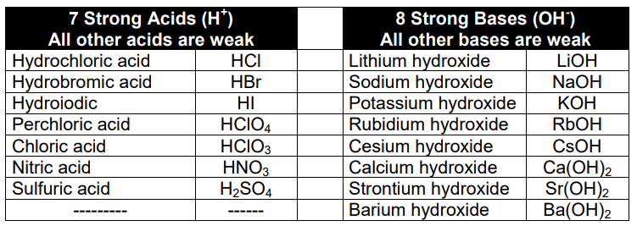

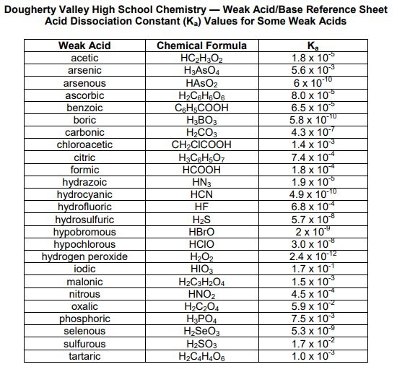

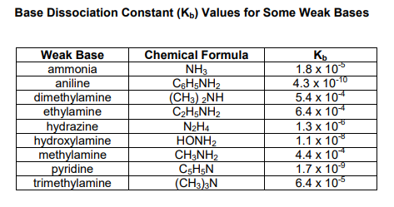 

|  |  |  |  |  |  |  |
| --- | --- | --- | --- | --- | --- | --- |
| **Salt** | | **Cation came from…** | **So Cation makes  the solution…** | **Anion came from…** | **So Anion makes  the solution…** | **So Salt is…Acidic, Basic, or Neutral?** |
| 1. NaNO2 | |  |  |  |  | *Think it through…* |
| *Cation is:* | *Anion is:* | *Which is a:* | *Ka(ion) or Kb(ion) if needed:* | *Which is a:* | *Ka(ion) or Kb(ion) if needed:* |  |
| 2. NH4CN | |  |  |  |  | *Think it through…* |
| *Cation is:* | *Anion is:* | *Which is a:* | *Ka(ion) or Kb(ion) if needed:* | *Which is a:* | *Ka(ion) or Kb(ion) if needed:* |  |
| 3. NH4OCl | |  |  |  |  | *Think it through…* |
| *Cation is:* | *Anion is:* | *Which is a:* | *Ka(ion) or Kb(ion) if needed:* | *Which is a:* | *Ka(ion) or Kb(ion) if needed:* |  |
| 4. CH3NH3CN | |  |  |  |  | *Think it through…* |
| *Cation is:* | *Anion is:* | *Which is a:* | *Ka(ion) or Kb(ion) if needed:* | *Which is a:* | *Ka(ion) or Kb(ion) if needed:* |  |
| **Salt** | | **Cation came from…** | **So Cation makes  the solution…** | **Anion came from…** | **So Anion makes  the solution…** | **So Salt is…Acidic, Basic, or Neutral?** |
| 5. KF | |  |  |  |  | *Think it through…* |
| *Cation is:* | *Anion is:* | *Which is a:* | *Ka(ion) or Kb(ion) if needed:* | *Which is a:* | *Ka(ion) or Kb(ion) if needed:* |  |
| 6. NH4NO2 | |  |  |  |  | *Think it through…* |
| *Cation is:* | *Anion is:* | *Which is a:* | *Ka(ion) or Kb(ion) if needed:* | *Which is a:* | *Ka(ion) or Kb(ion) if needed:* |  |
| 7. HONH3ClO4 | |  |  |  |  | *Think it through…* |
| *Cation is:* | *Anion is:* | *Which is a:* | *Ka(ion) or Kb(ion) if needed:* | *Which is a:* | *Ka(ion) or Kb(ion) if needed:* |  |
| 8. Na2CO3 | |  |  |  |  | *Think it through…* |
| *Cation is:* | *Anion is:* | *Which is a:* | *Ka(ion) or Kb(ion) if needed:* | *Which is a:* | *Ka(ion) or Kb(ion) if needed:* |  |
| **Salt** | | **Cation came from…** | **So Cation makes  the solution…** | **Anion came from…** | **So Anion makes  the solution…** | **So Salt is…Acidic, Basic, or Neutral?** |
| 9. NaBr | |  |  |  |  | *Think it through…* |
| *Cation is:* | *Anion is:* | *Which is a:* | *Ka(ion) or Kb(ion) if needed:* | *Which is a:* | *Ka(ion) or Kb(ion) if needed:* |  |
| 10. C6H5NH3Cl | |  |  |  |  | *Think it through…* |
| *Cation is:* | *Anion is:* | *Which is a:* | *Ka(ion) or Kb(ion) if needed:* | *Which is a:* | *Ka(ion) or Kb(ion) if needed:* |  |
| 11. LiC2H3O2 | |  |  |  |  | *Think it through…* |
| *Cation is:* | *Anion is:* | *Which is a:* | *Ka(ion) or Kb(ion) if needed:* | *Which is a:* | *Ka(ion) or Kb(ion) if needed:* |  |
| 12. Na2SO3 | |  |  |  |  | *Think it through…* |
| *Cation is:* | *Anion is:* | *Which is a:* | *Ka(ion) or Kb(ion) if needed:* | *Which is a:* | *Ka(ion) or Kb(ion) if needed:* |  |
| **Salt** | | **Cation came from…** | **So Cation makes  the solution…** | **Anion came from…** | **So Anion makes  the solution…** | **So Salt is…Acidic, Basic, or Neutral?** |
| 13. K2C2O4 | |  |  |  |  | *Think it through…* |
| *Cation is:* | *Anion is:* | *Which is a:* | *Ka(ion) or Kb(ion) if needed:* | *Which is a:* | *Ka(ion) or Kb(ion) if needed:* |  |
| 14. NaOBr | |  |  |  |  | *Think it through…* |
| *Cation is:* | *Anion is:* | *Which is a:* | *Ka(ion) or Kb(ion) if needed:* | *Which is a:* | *Ka(ion) or Kb(ion) if needed:* |  |
| 15. (CH3NH3)H2PO4 | |  |  |  |  | *Think it through…* |
| *Cation is:* | *Anion is:* | *Which is a:* | *Ka(ion) or Kb(ion) if needed:* | *Which is a:* | *Ka(ion) or Kb(ion) if needed:* |  |
| 16. NH4I | |  |  |  |  | *Think it through…* |
| *Cation is:* | *Anion is:* | *Which is a:* | *Ka(ion) or Kb(ion) if needed:* | *Which is a:* | *Ka(ion) or Kb(ion) if needed:* |  |
| **Salt** | | **Cation came from…** | **So Cation makes  the solution…** | **Anion came from…** | **So Anion makes  the solution…** | **So Salt is…Acidic, Basic, or Neutral?** |
| 17. KNO2 | |  |  |  |  | *Think it through…* |
| *Cation is:* | *Anion is:* | *Which is a:* | *Ka(ion) or Kb(ion) if needed:* | *Which is a:* | *Ka(ion) or Kb(ion) if needed:* |  |
| 18. C2H5NH3Cl | |  |  |  |  | *Think it through…* |
| *Cation is:* | *Anion is:* | *Which is a:* | *Ka(ion) or Kb(ion) if needed:* | *Which is a:* | *Ka(ion) or Kb(ion) if needed:* |  |