N1 Math Review Glue In  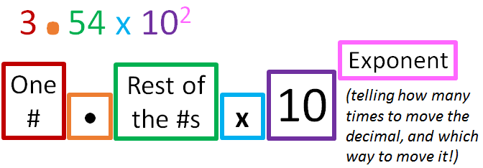  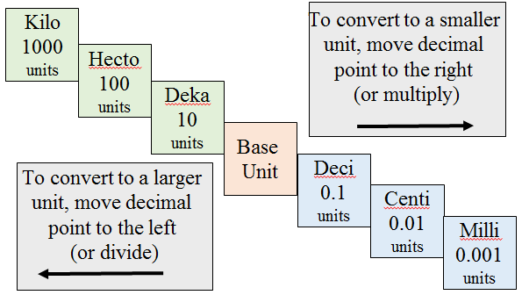 | N2 Dimensional Analysis Glue In  Metric to Metric English to Metric English to English  1 km = 1000 m 1 mile = 1.609 km 1 ft = 12 in  100 cm = 1 m 1 in = 2.54 cm 1 yd = 3 ft  1000 mm = 1 m 1 m = 39.37 in 1 mile = 5280 ft  1000 mg = 1 g 1 ft³ = 28.32 L 1 gallon = 4 qt  1000 g = 1 kg 1 L = 1.057qt 1 lb = 16 oz  1000 ml = 1 L 1 lb = 453.6 g 1 quart = 4 cups  1 cm³ = 1 ml 1 g = 0.03527 oz 1 pint = 2 cups
N4 Properties Changes Types of Matter Glue In

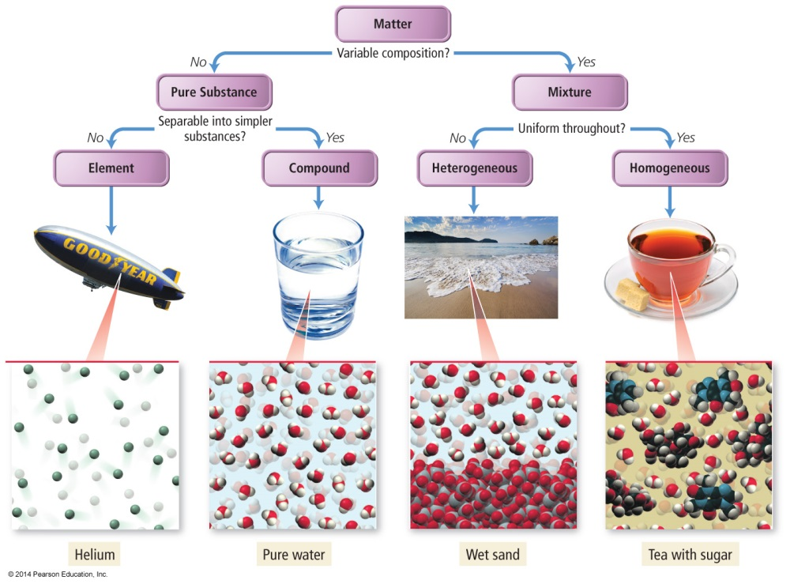
N5 Conclusions from Gold Foil Experiment

Conclusions from the Gold Foil Experiment
Most of the particles passed right through
A few particles were greatly deflected.
Very few were GREATLY deflected
N5 Conclusions from Study
of the Electron

Conclusions from the Study of the Electron |  |  | Conclusions from the Study of the Electron
Cathode rays have  identical properties regardless of element used |  |  | Cathode rays have  identical properties regardless of element used
Atoms are neutral |  |  | Atoms are neutral
Electrons have very  little mass compared  to the atom’s mass |  |  | Electrons have very  little mass compared  to the atom’s mass

N3 Glue In Significant Figures
Nonzero Integers | ALWAYS COUNT as SIGNIFICANT
Leading Zeros | NEVER COUNT as SIGNIFICANT
Captive Zeros | ALWAYS COUNT as SIGNIFICANT
Trailing Zeros | AFTER A DECIMAL  ALWAYS COUNT as SIGNIFICANT
SOMETIMES COUNT as SIGNIFICANT | NO DECIMAL  NEVER COUNT as SIGNIFICANT
Exact Numbers | INFINITE NUMBER  of sig figs
Multiplication & Division | Answer based on LEAST number of SIG FIGS in the problem
Addition & Subtraction | Answer based on LEAST number of DECIMAL PLACES in the problem

