|  |  |
| --- | --- |
| **Chemical Reactions** | **Nuclear Reactions** |
| Occur when bonds are broken | Occur when nuclei emit particles and/or rays |
| Atoms remain unchanged, although they may be rearranged | Atoms often converted into atoms of another element |
| Involve only valence electrons | May involve protons, neutrons, and electrons |
| Associated with small energy changes | Associated with large energy changes |
| Reaction rate influenced by temperature, particle size, concentration, etc. | Reaction rate is not influenced by temperature, particle size, concentration, etc. |

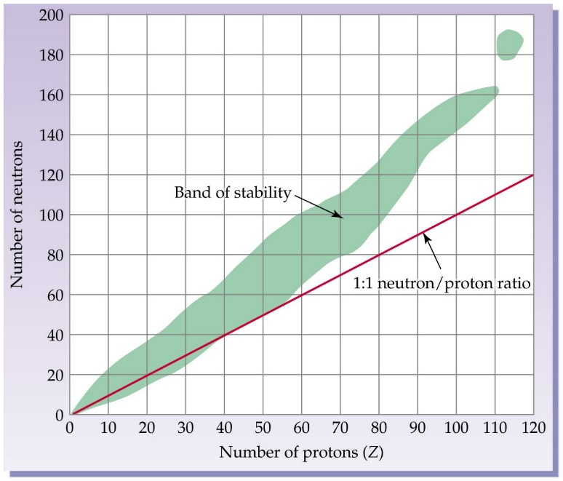

|  |  |  |  |  |
| --- | --- | --- | --- | --- |
| **Particle** | **Symbol** | **Composition** | **Charge** | **Mass** |
| **Alpha** | α | Helium Nuclei | +2 | 4 amu |
| **Shielding** | **Approx. Energy** | **Penetrating Power** | **Change to Mass #** | **Change to Atomic #** |
| Paper  Clothing | 5MeV | Low 0.05mm body tissue | -4 | -2 |
| **Particle** | **Symbol** | **Composition** | **Charge** | **Mass** |
| **Beta** | e-  β | Like an electron | -1 | 1/1837th amu basically 0 |
| **Shielding** | **Approx. Energy** | **Penetrating Power** | **Change to Mass #** | **Change to Atomic #** |
| Aluminum foil | 0.05-1MeV | Moderate 4mm body tissue | 0 | +1 |
| **Particle** | **Symbol** | **Composition** | **Charge** | **Mass** |
| **Gamma** | γ | High energy electromagnetic radiation | 0 | 0 |
| **Shielding** | **Approx. Energy** | **Penetrating Power** | **Change to Mass #** | **Change to Atomic #** |
| Lead Concrete | 1MeV | High  Penetrates easily | 0 | 0 |
| **Proton** | | **Neutron** | **Positron** | |
| $${}_{1}^{1}p$$ | | $${}_{0}^{1}n$$ | $${}_{+1}^{0}e$$ | |

N-6

|  |  |
| --- | --- |
| **Chemical Reactions** | **Nuclear Reactions** |
| Occur when bonds are broken | Occur when nuclei emit particles and/or rays |
| Atoms remain unchanged, although they may be rearranged | Atoms often converted into atoms of another element |
| Involve only valence electrons | May involve protons, neutrons, and electrons |
| Associated with small energy changes | Associated with large energy changes |
| Reaction rate influenced by temperature, particle size, concentration, etc. | Reaction rate is not influenced by temperature, particle size, concentration, etc. |



|  |  |  |  |  |
| --- | --- | --- | --- | --- |
| **Particle** | **Symbol** | **Composition** | **Charge** | **Mass** |
| **Alpha** | α | Helium Nuclei | +2 | 4 amu |
| **Shielding** | **Approx. Energy** | **Penetrating Power** | **Change to Mass #** | **Change to Atomic #** |
| Paper  Clothing | 5MeV | Low 0.05mm body tissue | -4 | -2 |
| **Particle** | **Symbol** | **Composition** | **Charge** | **Mass** |
| **Beta** | e-  β | Like an electron | -1 | 1/1837th amu basically 0 |
| **Shielding** | **Approx. Energy** | **Penetrating Power** | **Change to Mass #** | **Change to Atomic #** |
| Aluminum foil | 0.05-1MeV | Moderate 4mm body tissue | 0 | +1 |
| **Particle** | **Symbol** | **Composition** | **Charge** | **Mass** |
| **Gamma** | γ | High energy electromagnetic radiation | 0 | 0 |
| **Shielding** | **Approx. Energy** | **Penetrating Power** | **Change to Mass #** | **Change to Atomic #** |
| Lead Concrete | 1MeV | High  Penetrates easily | 0 | 0 |
| **Proton** | | **Neutron** | **Positron** | |
|  | |  |  | |

N-6