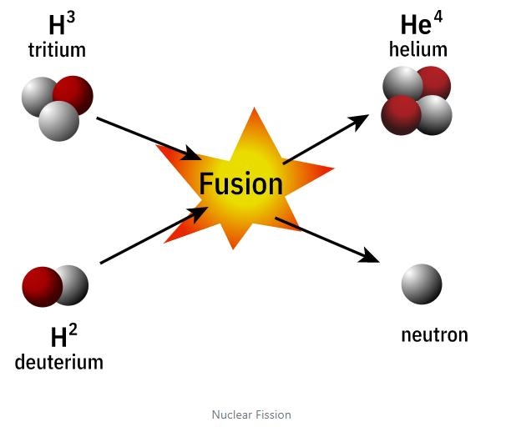<https://www.atomicarchive.com/science/fusion/index.html>

Nuclear Fusion: Basics

Nuclear energy can also be released by fusion of two light elements (elements with low atomic numbers). The power that fuels the sun and the stars is nuclear fusion.

In a hydrogen bomb, two isotopes of hydrogen, deuterium and tritium are fused to form a nucleus of helium and a neutron. This fusion releases 17.6 MeV of energy. Unlike nuclear fission, there is no limit on the amount of the fusion that can occur.

The Hydrogen Bomb: The Basics

A fission bomb, called the primary, produces a flood of radiation including a large number of neutrons. This radiation impinges on the thermonuclear portion of the bomb, known as the secondary. The secondary consists largely of lithium deuteride. The neutrons react with the lithium in this chemical compound, producing tritium and helium.

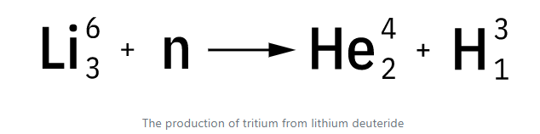This reaction produces the tritium on the spot, so there is no need to include tritium in the bomb itself. In the extreme heat which exists in the bomb, the tritium fuses with the deuterium in the lithium deuteride.

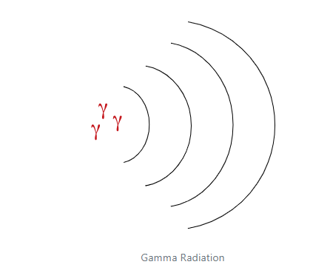The Hydrogen Bomb: The Secret

The question facing designers was "How do you build a bomb that will maintain the high temperatures required for thermonuclear reactions to occur?" The shock waves produced by the primary (A-bomb) would propagate too slowly to permit assembly of the thermonuclear stage (the secondary) before the bomb blew itself apart. This problem was solved by [Edward Teller](https://www.atomicarchive.com/resources/biographies/teller.html) and [Stanislaw Ulam](https://www.atomicarchive.com/resources/biographies/ulam.html).

To do this, they introduced a high energy gamma ray absorbing material (styrofoam) to capture the energy of the radiation. As high energy gamma radiation from the primary is absorbed, radial compression forces are exerted along the entire cylinder at almost the same instant. This produces the compression of the lithium deuteride. Additional neutrons are also produced by various components and reflected towards the lithium deuteride. With the compressed lithium deuteride core now bombarded with neutrons, tritium is formed and the fusion process begins.

The Hydrogen Bomb: Schematic

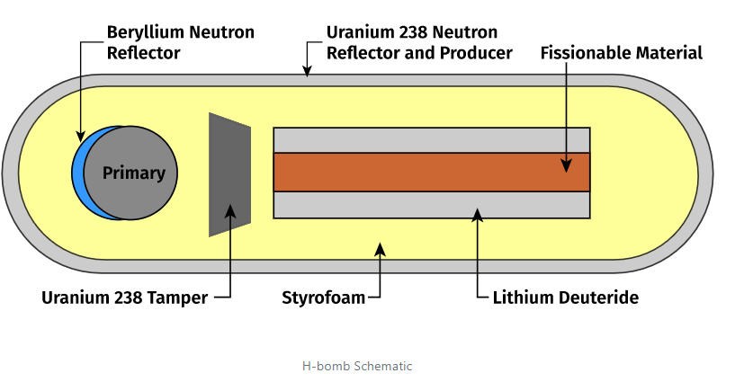

The yield of a hydrogen bomb is controlled by the amounts of lithium deuteride and of additional fissionable materials. Uranium 238 is usually the material used in various parts of the bomb's design to supply additional neutrons for the fusion process. This additional fissionable material also produces a very high level of radioactive fallout.

# The Neutron Bomb

The neutron bomb is a small hydrogen bomb. The neutron bomb differs from standard nuclear weapons insofar as its primary lethal effects come from the radiation damage caused by the neutrons it emits. It is also known as an enhanced-radiation weapon (ERW).

The augmented radiation effects mean that blast and heat effects are reduced so that physical structures including houses and industrial installations, are less affected. Because neutron radiation effects drop off very rapidly with distance, there is a sharper distinction between areas of high lethality and areas with minimal radiation doses.

This was desired by the forces of the North Atlantic Treaty Organization (NATO), since they have to be prepared to fight in densely populated areas; any tactical nuclear explosion will endanger civilian lives and property.