Cloud Chamber Prelab **Name: Period:**

**General**

* Filled out Headers
* Footer signed and dated
* Labeled Sections
* Adequate Spacing
* Professionalism/Care/Thought
* Extra sections included that were not asked for
* Other:

**Background**

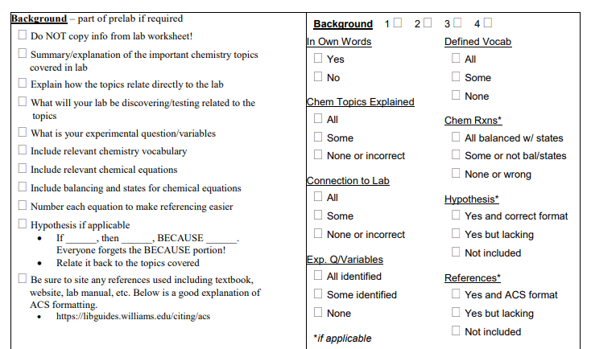

Cloud Chamber Prelab **Name: Period:**

**General**

* Filled out Headers
* Footer signed and dated
* Labeled Sections
* Adequate Spacing
* Professionalism/Care/Thought
* Extra sections included that were not asked for
* Other:

**Background**



|  |  |  |
| --- | --- | --- |
| **General** | 5 |  |
| **Background** | 10 |  |
| **Materials** | 5 |  |
| **Reagent Table** | 5 |  |
| **Procedure** | 5 |  |
| ***Total*** | 30 |  |

**Materials**

* All relevant materials included

**Reagent Table**

* All sections included
* All chemicals represented

**Procedure**

* In own words, not copied
* All numbered steps all represented
* Shortened version
* Drawings of set up included

|  |  |  |
| --- | --- | --- |
| **General** | 5 |  |
| **Background** | 10 |  |
| **Materials** | 5 |  |
| **Reagent Table** | 5 |  |
| **Procedure** | 5 |  |
| ***Total*** | 30 |  |

**Materials**

* All relevant materials included

**Reagent Table**

* All sections included
* All chemicals represented

**Procedure**

* In own words, not copied
* All numbered steps all represented
* Shortened version
* Drawings of set up included