Electron Configuration – an “address” for the electrons in an atom
An Orbital is:  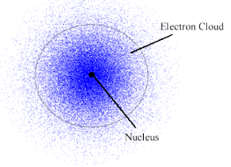 | How do we describe orbitals?
Different orbitals are in different energy levels | Different orbitals have different shapes
Different orbitals have different orientations | Each orbital is only allowed to have two e⁻s
Where do e- live? What is the address for one?  State ------> Energy level  City ------> Type/shape of orbital  Street ------> Orientation or orbital  House # ------> Spin up or spin down of e– |  | They can get REALLY long  1s_{+½ ,} 1s_{-½} ,2s_{+½ ,} 2s_{-½}  2p_{x +½ ,} 2p_{x -½ ,} 2p_{y +½}  2p_{y -½ ,} 2p_{z +½ ,} 2p_{z -½}  N-10

Want to describe where ALL the e- in an  atom were?  Shrink it down and only list:  Example: |  | Steps to finding all the electrons  - Pick an:  _____________________________________  - Find the number of:  _____________________________________  - Start putting electrons into the: _____________________________________  - Use an:  _____________________________________  - List which:  __________________________ you used and  __________________________ electrons in each one
Rules for putting electrons in an orbital diagram:

- Aufbau Principle  An electron occupies the lowest energy orbital that it can.  Means: | - Pauli Exclusion Principle  No two e⁻s in the same atom can have the same set of 4 quantum numbers  Means: |  | - Hunds Rule  Orbitals of equal energy are each occupied by one e⁻ before any orbital is occupied by a second e⁻.  Means:
Some Terms You Might Hear
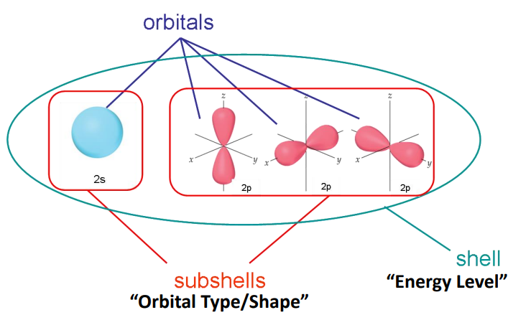

N-10

