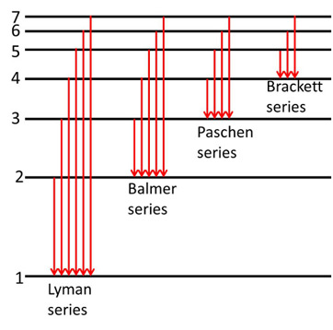

N-14



N-14



N-14



N-14