**Worksheet #3**

**Name: Period: Seat#:**

An electron configuration is a method of indicating the arrangement of electrons about a nucleus. A typical electron configuration consists of numbers, letters, and superscripts with the following format:

1. A number indicates the energy level (The number is called the principal quantum number, and is represented by an n typically).
2. A letter indicates the type of orbital: s, p, d, f.
3. A superscript indicates the number of electrons in the orbital. Example 1s2 means that there are two electrons in the “s” orbital in the first energy level. That element would be Helium.

To write an electron configuration:

1. Determine the total number of electrons to be represented.
2. Use the Aufbau principal to fill the orbitals with electrons. The Aufbau principal requires that the electrons fill the lowest energy orbitals first. In other words, atoms are built from the “ground up.” You can use an orbital diagram to help you determine the order that the orbitals come in. You can also use a periodic table to tell you the same information based on the patterns on the table.
3. List the energy level, orbital type, and number of electrons used for each orbital filled with electrons. This list is the “electron configuration.”
4. The sum of the superscripts should equal the total number of electrons. For example: 1s22s22p63s2 is Magnesium because it has 12 electrons (2+2+6+2=12)

**Configuration Writing Practice**Write a “ground state” electron configuration for each neutral atom. Ground state means that all of the lowest possible energy levels are filled – in other words, it means that the Aufbau principle is being followed. If an atom is in an “excited state” it means that the atom was given extra energy and it caused some electrons to be pushed to higher energy levels/orbitals which actually breaks the Aufbau principle. We will learn more about “excited states” later in the chapter. Ground state configurations are often just called “normal” configurations.

|  |  |  |
| --- | --- | --- |
| **Q#** | **Total # e-** | **Electron Configuration** |
| 1. Na |  |  |
| 1. Pb |  |  |
| 1. Sr |  |  |
| 1. U |  |  |
| 1. N |  |  |
| 1. Ag |  |  |
| 1. Ti |  |  |
| 1. Ce |  |  |
| 1. Cl |  |  |
| 1. Hg |  |  |

1. 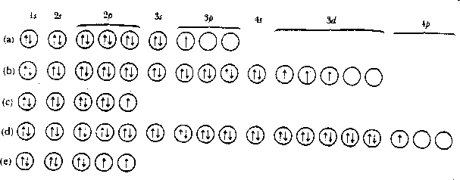Write the corresponding electron configuration for each of the following pictorial representations. Name the element that each picture represents, assuming they are neutral atoms

|  |  |  |  |
| --- | --- | --- | --- |
| **Q** | **Total # e-** | **Name** | **Electron Configuration** |
| **a** |  |  |  |
| **b** |  |  |  |
| **c** |  |  |  |
| **d** |  |  |  |
| **e** |  |  |  |

1. Indicate which groups of elements have an outer configuration indicated below. \**you can just list which atomic numbers fulfill each requirement. Some chemists call these various elements the s-block, p-block, d-block and f-block*

|  |  |
| --- | --- |
| s electron configuration |  |
| p electron configuration |  |
| d electron configuration |  |
| f electron configuration |  |

1. Determine the element of the lowest atomic number whose “ground state” contains:

|  |  |
| --- | --- |
| Three d electrons |  |
| A complete d set/subshell |  |
| Ten total p electrons |  |
| An f electron |  |
| 13 d electrons |  |
| 23 p electrons |  |
| 7 s electrons |  |

1. How many total p electrons are there in the ground state of a phosphorus atom?
2. What is the maximum number of electrons that can be accommodated in an energy level of n=3? In other words, how many electrons can the third energy level hold all together?