**Worksheet #4**

**Name: Period: Seat#:**

1. Neon

|  |  |  |  |  |  |  |  |  |  |  |  |  |  |  |  |  |  |  |
| --- | --- | --- | --- | --- | --- | --- | --- | --- | --- | --- | --- | --- | --- | --- | --- | --- | --- | --- |
| **Orbital diagram** |  |  |  |  |  |  |  |  |  |  |  |  |  |  |  |  |  |  |
| **Electron configuration** |  | | | | | | | | | | | | | | | | | |
| **E.C.**  **using noble gas notation** |  | | | | | | | | | | | | | | | | | |

1. Magnesium

|  |  |  |  |  |  |  |  |  |  |  |  |  |  |  |  |  |  |  |
| --- | --- | --- | --- | --- | --- | --- | --- | --- | --- | --- | --- | --- | --- | --- | --- | --- | --- | --- |
| **Orbital diagram** |  |  |  |  |  |  |  |  |  |  |  |  |  |  |  |  |  |  |
| **Electron configuration** |  | | | | | | | | | | | | | | | | | |
| **E.C.**  **using noble gas notation** |  | | | | | | | | | | | | | | | | | |

1. Chlorine

|  |  |  |  |  |  |  |  |  |  |  |  |  |  |  |  |  |  |  |
| --- | --- | --- | --- | --- | --- | --- | --- | --- | --- | --- | --- | --- | --- | --- | --- | --- | --- | --- |
| **Orbital diagram** |  |  |  |  |  |  |  |  |  |  |  |  |  |  |  |  |  |  |
| **Electron configuration** |  | | | | | | | | | | | | | | | | | |
| **E.C.**  **using noble gas notation** |  | | | | | | | | | | | | | | | | | |

1. Potassium

|  |  |  |  |  |  |  |  |  |  |  |  |  |  |  |  |  |  |  |
| --- | --- | --- | --- | --- | --- | --- | --- | --- | --- | --- | --- | --- | --- | --- | --- | --- | --- | --- |
| **Orbital diagram** |  |  |  |  |  |  |  |  |  |  |  |  |  |  |  |  |  |  |
| **Electron configuration** |  | | | | | | | | | | | | | | | | | |
| **E.C.**  **using noble gas notation** |  | | | | | | | | | | | | | | | | | |

1. Iron

|  |  |  |  |  |  |  |  |  |  |  |  |  |  |  |  |  |  |  |
| --- | --- | --- | --- | --- | --- | --- | --- | --- | --- | --- | --- | --- | --- | --- | --- | --- | --- | --- |
| **Orbital diagram** |  |  |  |  |  |  |  |  |  |  |  |  |  |  |  |  |  |  |
| **Electron configuration** |  | | | | | | | | | | | | | | | | | |
| **E.C.**  **using noble gas notation** |  | | | | | | | | | | | | | | | | | |

1. Krypton

|  |  |  |  |  |  |  |  |  |  |  |  |  |  |  |  |  |  |  |
| --- | --- | --- | --- | --- | --- | --- | --- | --- | --- | --- | --- | --- | --- | --- | --- | --- | --- | --- |
| **Orbital diagram** |  |  |  |  |  |  |  |  |  |  |  |  |  |  |  |  |  |  |
| **Electron configuration** |  | | | | | | | | | | | | | | | | | |
| **E.C.**  **using noble gas notation** |  | | | | | | | | | | | | | | | | | |

1. Write the corresponding NOBLE GASS configuration for each of the following pictorial representations. Name the element assuming that the configuration describes a neutral atom.

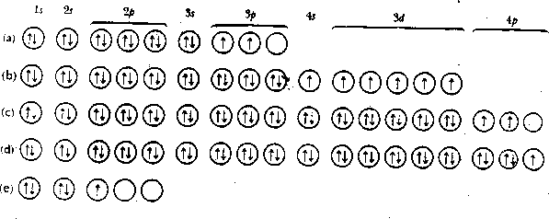



|  |  |  |  |
| --- | --- | --- | --- |
| **Q** | **Total # e-** | **Name** | **Noble Gas Configuration** |
| a |  |  |  |
| b |  |  |  |
| c |  |  |  |
| d |  |  |  |
| e |  |  |  |

1. Which group of elements has a noble gas configuration that ends in ns2?