
Name: Period: Seat #:
Worksheet #1
DECK LETTER: _________ PowerPoint Shown In Class: https://tinyurl.com/npp6cvtd

Introduction
- Your task is to arrange the Aliens in some logical pattern so that they form an organized rectangular block.
- Within each group, all the Aliens in that group must be exactly the same in some way (the Key Similarity), AND must also share a feature that changes regularly as you move down the group (the Varying Trait).
- Within each period, all the Aliens in the period must be exactly the same in some way (the Key Similarity), AND must also share a feature that changes regularly as you move across the period (the Varying Trait).
- Two Aliens are missing from your set; simply leave empty spaces in your rectangular block for these Aliens.
- Once you have finished arranging your Aliens, have your teacher check it
- Be prepared to answer any questions the teacher may have about how you arranged the Aliens. Good luck!

1) GIVE DETAILED INFORMATION ABOUT YOUR TABLE OF ALIENS.

 | How Many? | Key Similarity | Varying Trait
GROUPS
PERIODS

2) ALL ABOUT THE MISSING ALIENS – for each alien, list five descriptions of what it looks like and draw it neatly.

Description Of Missing Alien #1 | Drawing Of Missing Alien #1
I.

II.

III.

IV.

V.

Description Of Missing Alien #2 | Drawing Of Missing Alien #2
I.

II.

III.

IV.

V.

3) PREDICT THE ‘NEXT’ ALIEN? – Pick a NEW group and period that is not already part of your alien table.
Describe what the ‘Next’ Alien might look like, and neatly draw what it might look like.

 | Description Of The “Next” Alien | Drawing Of The “Next” Alien
GROUP # | The “next” alien almost certainly has....
PERIOD # | Things about the “next” alien we really don’t know...

4) CONNECTION TO THE ACTUAL PERIODIC TABLE – The Periodic Table arranges the elements in a way that allows us to see several patterns in an easy and visual way based on where the element is placed on the table. Look at the diagrams below and try to figure out the patterns for each property. Fill in an estimate for the missing values.

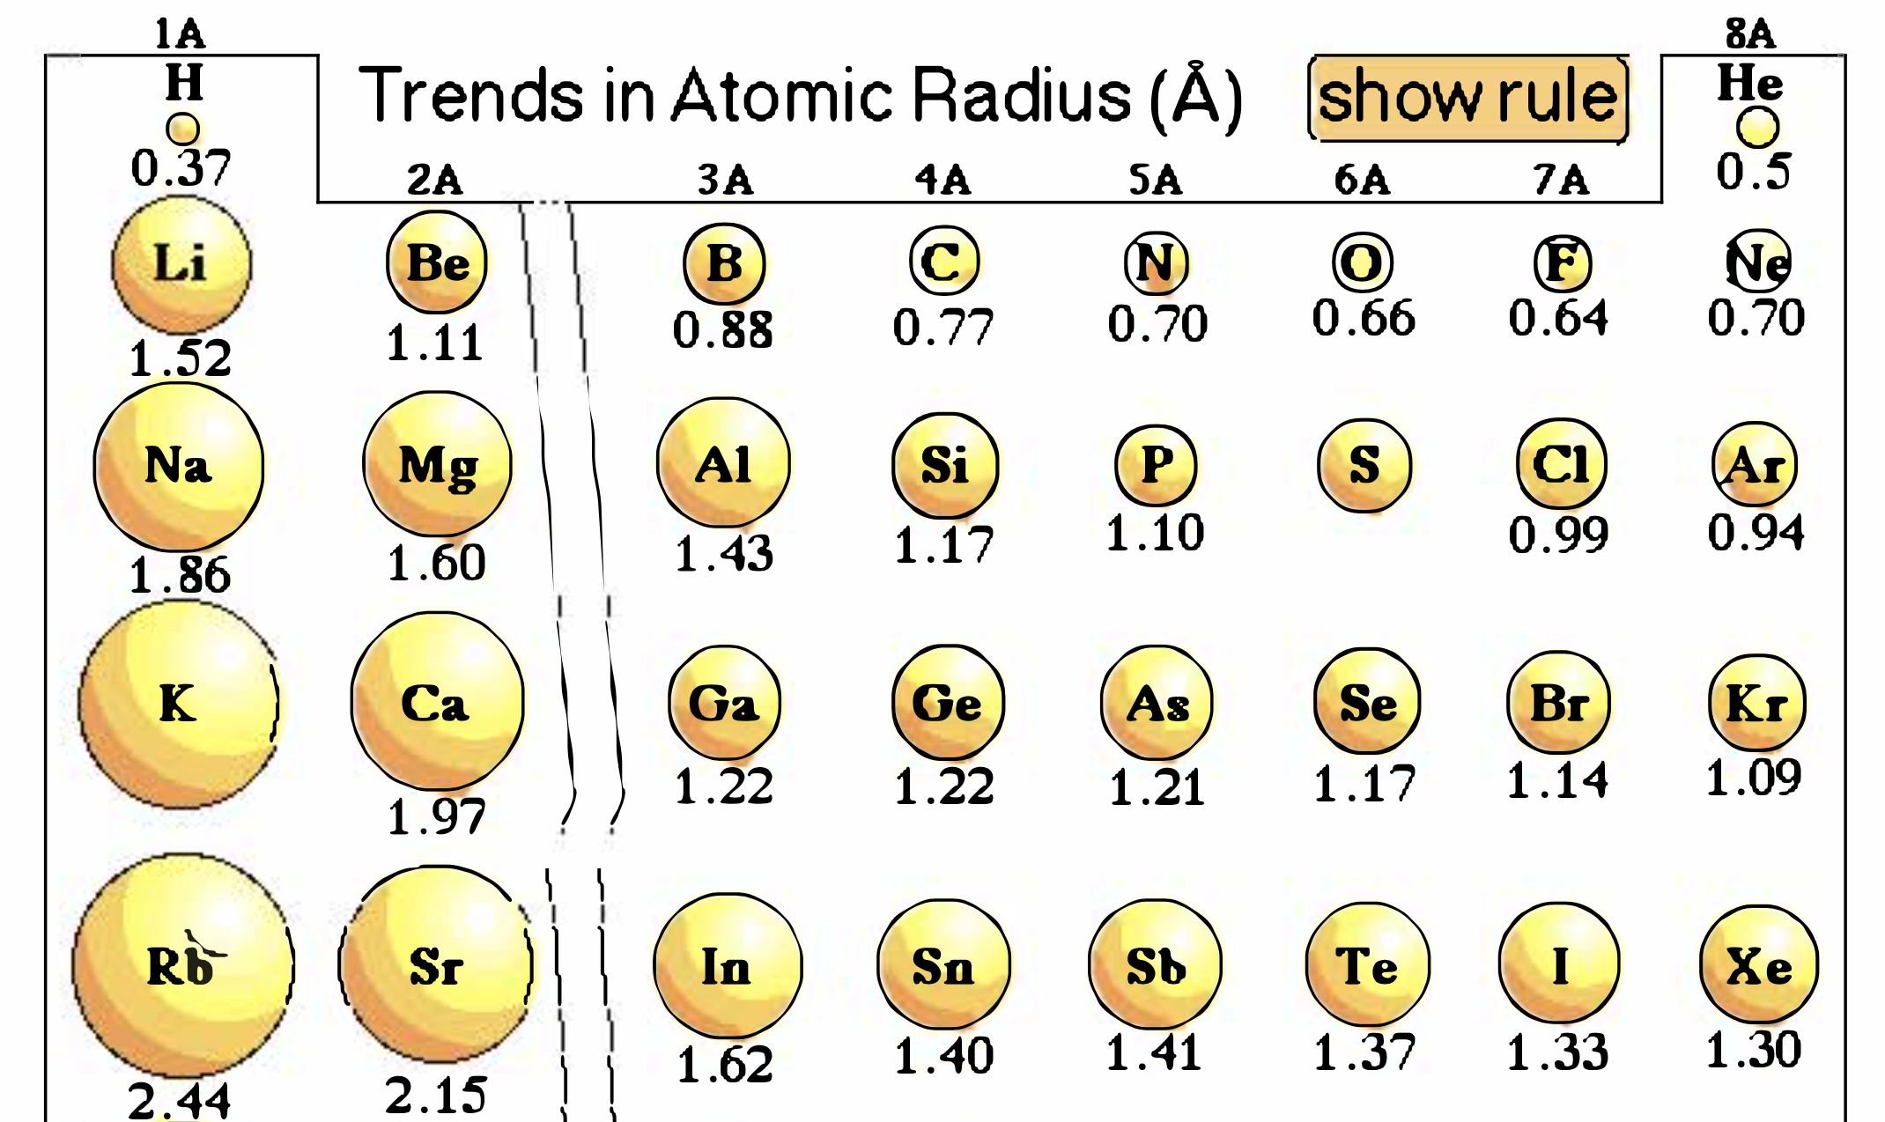 |  | Describe the reasoning  for your predictions.
Predicted Radius for Sulfur | Predicted Radius for Potassium

5) PREVIEW OF NEW PROPERTIES/PATTERNS – The Periodic Table has more properties/patterns than just the atomic radius seen in Question 4. Use the internet to research a chemistry definition for each of these other properties we will be learning about later in the chapter.

Ionization Energy
Electronegativity
Electron Affinity

