EVERYTHING is about...  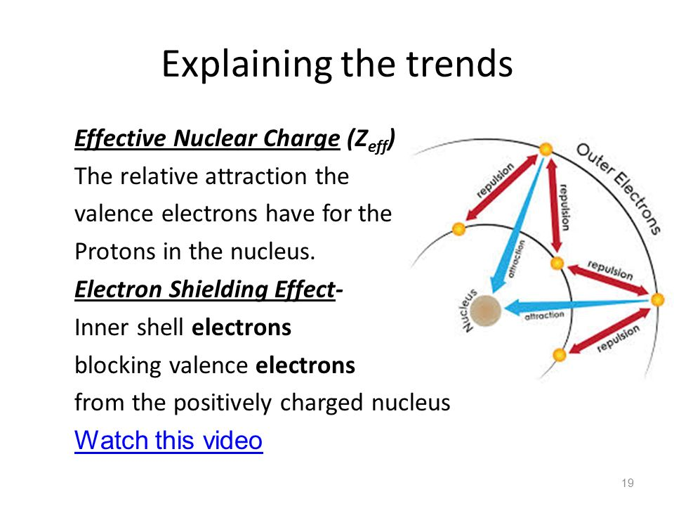  Shielding Effect  Inner shell electrons __________________  the outer ___________________ electrons  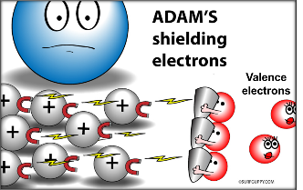  Keeps valence electrons from feeling the:  Effective Nuclear Charge (Z_{eff})  The relative _________________ the valence electrons have for the ________________ in the nucleus.  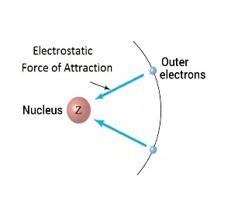  Adding a proton has a ____________ effect than adding an e- .  Zeff = _____________________  Z = nuclear attraction = # protons  S = core/inner e- shielding the valence e-  = total number of e- minus the e- in the  highest occupied s and p energy levels  Magnesium:  Aluminum: | Radius  What is it?  INCREASES DOWN because....  Increased or Increased  Shielding Nuclear Charge  DECREASES TO RIGHT because....  Increased or Increased  Shielding Nuclear Charge  Ionic Radius  Cations Anions  Isoelectric Species  Atoms/Ions that have the same # of ________  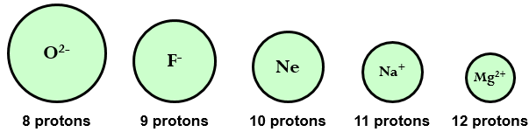  - Increased protons pull ______________  on valence electrons.  - Radius ends up ___________________  N-15
Ionization Energy  What is it?  DECREASES DOWN because....  Increased or Increased  Shielding Nuclear Charge  INCREASES TO RIGHT because....  Increased or Increased  Shielding Nuclear Charge  Subsequent Ionizations  - Each time e- removed  _________________ to take next one  - Radius is getting ________________  _________________ attraction  - HUGE leap in I.E. once it achieves  ______________________________  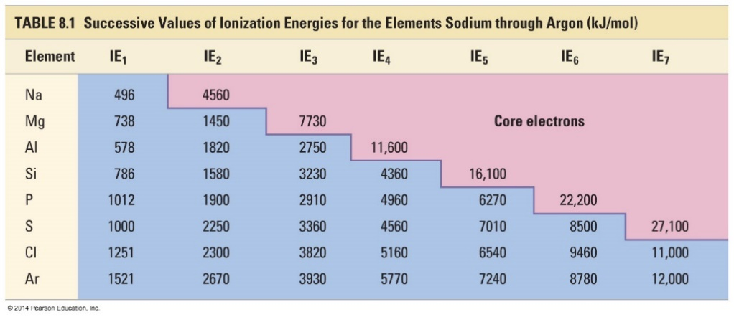  N-15 | Electronegativity  What is it?  DECREASES DOWN because....  Increased or Increased  Shielding Nuclear Charge  INCREASES TO RIGHT because....  Increased or Increased  Shielding Nuclear Charge
Reactivity  What is it?  METALS INCREASE DOWN because....  Increased or Increased  Shielding Nuclear Charge  NON-METALS INCREASE UP because....  Increased or Increased  Shielding Nuclear Charge | 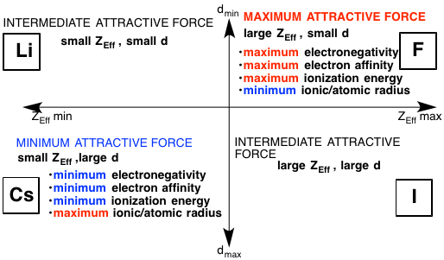  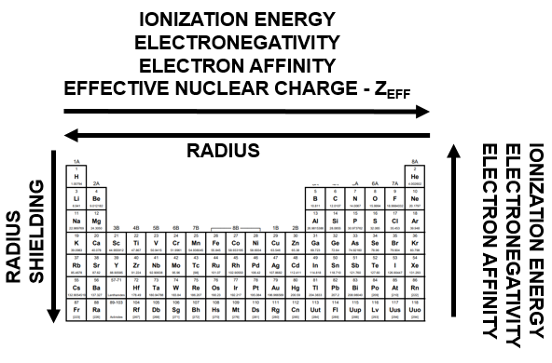
N-15

