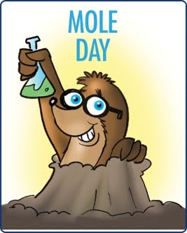**Mole Day Sign-Up Sheet**  
Period A 1 2 4

**Plain Sugar Cookies:**

______________________ (12)

______________________ (12)

______________________ (12)

______________________ (12)

______________________ (12)

______________________ (12)

**Frosting:**

Chocolate:_______________

Vanilla:_________________

Strawberry: ______________

**M&Ms (large bag)**

________________________

________________________

________________________

**Small Candies (chocolate chips, BBs, etc)**

_______________________

_______________________

_______________________

**Plastic Knives (12 count)**

_______________________

**Milk or Juice (specify which)**

_______________________

_______________________

_______________________

**Cups (36 count)**

_______________________

**Paper plates (36 count)**

_______________________

**Napkins**

_______________________

**Mole Day Sign-Up Sheet**   
Period A 1 2 4

**Plain Sugar Cookies:**

______________________ (12)

______________________ (12)

______________________ (12)

______________________ (12)

______________________ (12)

______________________ (12)

**Frosting:**

Chocolate:_________________

Vanilla:_________________

Strawberry: _________________

**M&Ms (large bag)**

________________________

________________________

________________________

**Small Candies (chocolate chips, BBs, etc)**

_______________________

_______________________

_______________________

**Plastic Knives (12 count)**

_______________________

**Milk or Juice (specify which)**

_______________________

_______________________

_______________________

**Cups (36 count)**

_______________________

**Paper plates (36 count)**

_______________________

**Napkins**

_______________________