Steps to Draw Lewis Dot Structures  - Count and sum valence electrons  - Place atoms  - Hydrogen is always on the outside  - Least electronegative atom in the center  - Symmetry is good! When possible  - Bond all atoms with a single bond  - Give all atoms a full shell  - Re-count the # of e- used  - Fix if Needed:  Used too few? Give them to the central atom  Used too many? Try double or triple bonds to fix it!  - Take a pair away from two neighboring atoms  - Put a pair between them to form the extra bond  - “Take two away, put one back in between”  - Correct number of valence electrons used ???  - Is each atom “happy” now ??? | Exceptions to the Octet Rule  Some elements have a tendency to break the octet rule. This is a list of the common ones that break the rule. Please know that you should always draw the best structure possible, and sometimes that means something will break the octet rule even if it isn’t listed here. You can only do the best you can do!  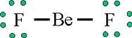  - H – 2  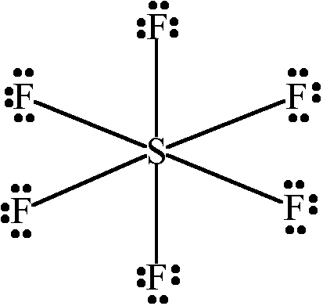  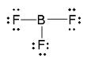  - Li - 2  - Be - 4  - B - 6  - P - 10  - S – 12  *Larger than 8 is called an “expanded octet.”  Phosphorus and Sulfur do not have to make an expanded octet, but they can if needed.  N-18

N-18
Steps to Draw Lewis Dot Structures  - Count and sum valence electrons  - Place atoms  - Hydrogen is always on the outside  - Least electronegative atom in the center  - Symmetry is good! When possible  - Bond all atoms with a single bond  - Give all atoms a full shell  - Re-count the # of e- used  - Fix if Needed:  Used too few? Give them to the central atom  Used too many? Try double or triple bonds to fix it!  - Take a pair away from two neighboring atoms  - Put a pair between them to form the extra bond  - “Take two away, put one back in between”  - Correct number of valence electrons used ???  - Is each atom “happy” now ??? | Exceptions to the Octet Rule  Some elements have a tendency to break the octet rule. This is a list of the common ones that break the rule. Please know that you should always draw the best structure possible, and sometimes that means something will break the octet rule even if it isn’t listed here. You can only do the best you can do!  - H – 2  - Li - 2  - Be - 4  - B - 6  - P - 10  - S – 12  *Larger than 8 is called an “expanded octet.”  Phosphorus and Sulfur do not have to make an expanded octet, but they can if needed.

Steps to Draw Lewis Dot Structures  - Count and sum valence electrons  - Place atoms  - Hydrogen is always on the outside  - Least electronegative atom in the center  - Symmetry is good! When possible  - Bond all atoms with a single bond  - Give all atoms a full shell  - Re-count the # of e- used  - Fix if Needed:  Used too few? Give them to the central atom  Used too many? Try double or triple bonds to fix it!  - Take a pair away from two neighboring atoms  - Put a pair between them to form the extra bond  - “Take two away, put one back in between”  - Correct number of valence electrons used ???  - Is each atom “happy” now ??? | Exceptions to the Octet Rule  Some elements have a tendency to break the octet rule. This is a list of the common ones that break the rule. Please know that you should always draw the best structure possible, and sometimes that means something will break the octet rule even if it isn’t listed here. You can only do the best you can do!  - H – 2  - Li - 2  - Be - 4  - B - 6  - P - 10  - S – 12  *Larger than 8 is called an “expanded octet.”  Phosphorus and Sulfur do not have to make an expanded octet, but they can if needed.  N-18

