Name: Period: Seat#:
Worksheet #4
Answer the following questions about compounds and molecules:
- What type of charge does a cation have? | - What type of charge does an anion have? |  | - Why do atoms form ions?
- What does “neutral compound” mean? |  | - Draw a cartoon picture using puzzle pieces to represent why LiO is not neutral, but Li₂O is neutral.

Identify if each item is ionic, covalent, or metallic:
- (NH₄)₂O | - N₂O₂ | - SO₂
- P₄O₁₀ | - Cu | - Mg₃(PO₃)₂

Calculate the electronegativity difference:
You can actually measure how ionic or covalent a bond is by subtracting “electronegativity values.” It is a measure of how hard the atom is able to pull on the electrons. If it can pull hard enough then it is an ionic bond because the electrons are considered to have been transferred. If they cannot pull hard enough then it is a covalent bond because the electrons are considered to still be shared, if they are shared unequally it is called “polar covalent” meaning it isn’t quite ionic yet, but it isn’t perfectly shared. Use the following information to determine where each bond lies. Show your calculations to justify your answers.
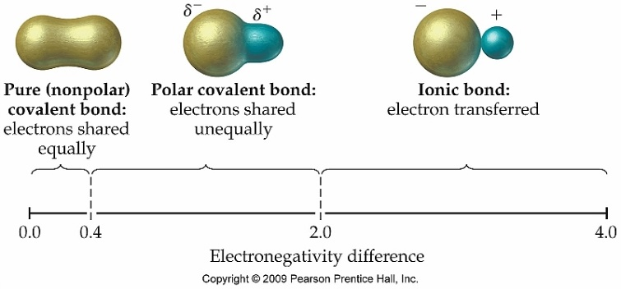  1.7  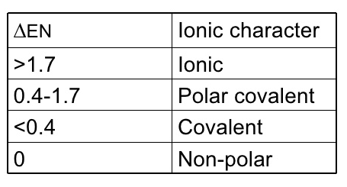 |  |  |  | - NO
 |  |  |  | - MgO
 |  |  |  | - Br₂
 |  |  |  | - LiH
 |  |  |  | - LiBr
 |  |  |  | - H₃P
H = 2.1 | N = 3.0 | Mg = 1.2 | Cl = 3.0 | - ClBr
Li = 1.0 | O = 3.5 | P = 2.1 | Br = 2.8 | * You can look up electronegativity values online, or you would be given them. You are not expected to memorize the values for each atom, but you should know the range of electronegativity differences and which type of bond that results in.

Write the formulas for the following compounds. For these problems you must show your “crossing over” work to earn credit. Don’t forget to look for polyatomic ions, don’t forget to reduce subscripts when possible, and rewrite your final answer clearly.
- Beryllium oxide | - Sodium sulfate | - Magnesium hydroxide
- Copper (I) chloride | - Zinc carbonate | - Ammonium nitrate
- Iron (III) sulfite | - Vanadium (V) fluoride | - Manganese (IV) nitride

Write the neutral formulas indicated by the chart. The first one was done for you. If you need to still do the “crossing over” method that’s ok! You can do it on a piece of binder paper and staple it to this paper. If you can do it in your head that’s great! That is the goal!
 |  | Zinc  Zn²⁺ | Iron (II)  Fe²⁺ | Iron (III)  Fe³⁺ | Gallium | Silver | Lead (IV)
Chloride  Cl⁻ |  | ZnCl₂
Acetate
Nitrate
NO₃⁻
Oxide
Nitride
Sulfate

