**DVHS Chemistry**

**Indications of Chemical Reactions Reader**

**Directions:**   
Read this page and take notes and/or annotate it. We will not be doing a traditional lecture on this material, instead we will be practicing its application in class. There is potentially information in here you may not be familiar with. If you come across anything you do not understand you need to ask about it! These are selections of reading by various people, credit given when possible.

**An Intro to Chemical Reactions –** *by John T. Moore. Edited to suit our purposes here.*

In a chemical reaction, substances (elements and/or compounds) called *reactants* are changed into other substances (compounds and/or elements) called *products*. Reactants are found on the left side of a reaction arrow and products on the right. In ordinary chemical reactions, the total mass of reacting substances is equal to the total mass of products – think of the Law of Conservation of Mass! All atoms on the reactant side must appear on the product side, and in equal numbers. No new elements may appear and no elements may disappear. Coefficients are used to indicate the number of molecules needed to ensure this *balance*. Notice in the image below, there are a total of 4 hydrogen atoms on the left (reactant) side of the reaction AND 4 hydrogen atoms on the right (products) side.

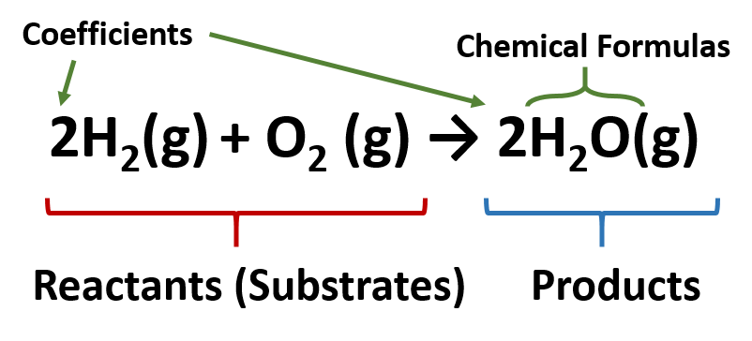

**Indications of a Chemical Reaction –** *by John T. Moore. Edited to suit our purposes here.*

A number of clues show that a chemical reaction has taken place, for example:

* Heat and/or light is given off (an *exothermic* reaction) or taken in (an *endothermic* reaction)
* Formation of a gas (sometimes a new odor or bubbles will help you notice a gas being given off)
* Formation of a precipitate (solid from two liquid state reactants)
* Color change

**Practice Identifying Evidence of Reactions –** *by Hybrid Librarian.*

Watch the video linked from the QR code below. For each reaction, note the evidence you see for each reaction.



1.

2.

3.

4.

5.

6.

7.

8.

9.

10.

**States of Matter in Chemical Reactions**

You will often see states of matter indicated just to the right of a chemical compound in a reaction and are found in subscript parentheses.

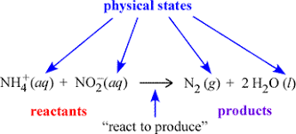

(g) = gaseous state

(l) = liquid

(aq) = aqueous (dissolved in water)

(s) = solid