**Name: Period: Seat#:**

**Worksheet #1**

**Directions:**   
Read this page and take notes and/or annotate it. We will not be doing a traditional lecture on this material, instead we will be practicing its application in class. There is potentially information in here you may not be familiar with. If you come across anything you do not understand you need to ask about it! These are selections of reading by various people, credit given when possible.

**An Intro to Chemical Reactions –** *by John T. Moore. Edited to suit our purposes.*

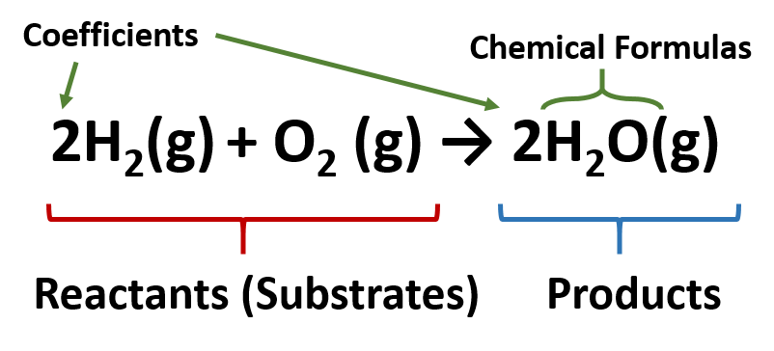In a chemical reaction, substances (elements and/or compounds) called *reactants* are changed into other substances (compounds and/or elements) called *products*. Reactants are found on the left side of a reaction arrow and products on the right. In ordinary chemical reactions, the total mass of reacting substances is equal to the total mass of products – think of the Law of Conservation of Mass! All atoms on the reactant side must appear on the product side, and in equal numbers. No new elements may appear and no elements may disappear. Coefficients are used to indicate the number of molecules needed to ensure this *balance*. Notice in the image below, there are a total of 4 hydrogen atoms on the left (reactant) side of the reaction AND 4 hydrogen’s on the right (products) side

**Indications of a Chemical Reaction –** *by John T. Moore. Edited to suit our purposes.*

A number of clues show that a chemical reaction has taken place, for example:

* Heat and/or light is given off (*exothermic* rxn) or taken in (*endothermic* rxn)
* Formation of a gas (sometimes a new odor or bubbles will help you notice a gas being given off)
* Formation of a precipitate (solid from two liquid state reactants)
* Color change

**Practice Identifying Evidence of Reactions –** *by Hybrid Librarian.*

Watch the video linked from the QR code below. For each reaction, note the evidence you see for each reaction. <https://tinyurl.com/2ud3rney>



10.

9.

8.

7.

6.

5.

4.

3.

2.

1.

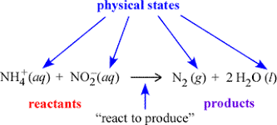

**States of Matter in Chemical Reactions**

You will often see states of matter indicated just to the right of a chemical compound in a reaction and are found in subscript parentheses.

(g) = gaseous state

(l) = liquid

(aq) = aqueous (dissolved in water)

(s) = solid

**Signs of a Chemical Reaction**

There are several ways to tell if a chemical reaction has occurred.

* Color change
* Odor change
* Formation of a gas
* Formation of a precipitate   
  (solid that forms when two liquids are mixed together)
* Temperature change (absorbing or releasing heat)
* Releasing light (a form of energy)

Sometimes it is very obvious when one of these changes occurs, sometimes it is so subtle it is difficult to detect with the human eye and you might need to use special equipment or instruments to detect the changes.

*Give a real life example for the following signs of a chemical reaction:*

|  |  |  |  |  |
| --- | --- | --- | --- | --- |
| 1. Color change | 1. Odor change | 1. Formation of a gas | 1. Temperature change | 1. Releasing light |

**Types of Reactions**

Chemical reactions can be classified into different categories based on patterns of what the reactants and products are like. Categorizing reactions into different types is helpful because it allows us to make predictions about what products could be formed based on following the patterns. Below are some cartoon images that summarize the main types of reactions we will learn about in this chapter. There are lots and lots of subcategories, but these are the big main ones.

*Synthesis Decomposition*

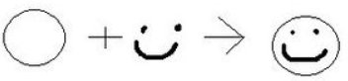

*Single Replacement Double Replacement*

 **

*Combustion*

*Using the cartoon pictures to help you, determine which type of reaction each of the following is:*

1. Ca + S 🡪 CaS _____________________________
2. Fe + MgO 🡪 Mg + FeO _____________________________
3. AlP 🡪 Al + P _____________________________
4. CH4 + 2O2 🡪 2H2O + CO2 + heat _____________________________
5. NaF + KI 🡪 NaI + KF _____________________________

