LIMITED KEY TO SOME OF WS #4 - The final answers to the Net Ionic Problems

The full keys will be posted later, but this way you can see if you got it right or not.

**17)** 

**18)** 

**19)** 



**20)** 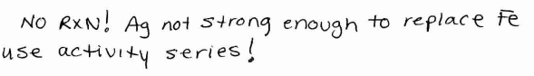

**21)** 

**22)** 

**23)** 

**24)** 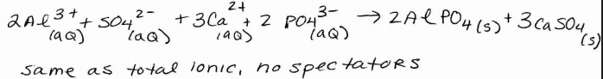

**25)** 

**26)** 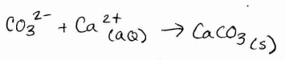

**27)** 