**Name: Period: Seat#:**

**Worksheet #7B**

**Required Sections:** (Refer to R-5 for guidelines and requirements. Make note of any specific changes given by your teacher in class)

**Prelab:** *All written in your lab notebook –* Answer Pre-Lab Questions, Materials, Reagent Table, Procedures,

**During Lab:** *Data Tables are part of the actual Lab Handout this time!*

**Post-lab:** *- The written equations on the actual Lab Handout are the post lab questions this time!*

**Directions:**

* Use the following links to observe the reactions.
* For Reactions #1-3 you do not need to watch the entire video, you don’t even need sound on. Just scroll through the video so you can observe what happens.
* For Reaction #4 please watch with the sound on and part of your observation should be little notes about the topics/examples discussed in the video.
* Record your observations as if you were doing them in the lab. Staple this paper to the back of WS #7.

**Reaction #1**

* <https://tinyurl.com/3rmnbcm4>

**Reaction #2**

* Same as what is on the normal handout

**Reaction #3**

* 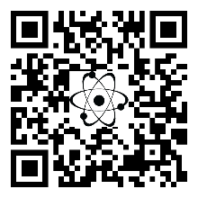<https://tinyurl.com/u4h6shg>

**Reaction #4**

* It is showing SrCl2, not CaCl2. That is ok! It is functionally the same. We are using CaCl2 because it is less hazardous to dispose of than SrCl2.
* <https://tinyurl.com/uxhzynt>

