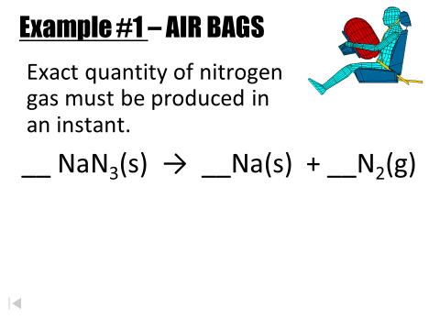

N-27

N-27