Empirical Formula Post Lab Grade Sheet Name: Period:
General

- Headers not filled out
- Footers not signed/dated
- Sections not labeled
- Not adequate spacing
- Lack of Professionalism/Care/Thought
- Extra sections included that were not asked for
- Other:

Observations/Data Tables

- Missing either qualitative or
quantitative data
- No title on data tables
- Titles not descriptive
- Too small/squished/messy
- Observations lacking detail or content

Calculations

- Work not shown  - 1  - 2  - 3  - 4  - 5  - 6  - 7 | - Work Insufficient  - 1  - 2  - 3  - 4  - 5  - 6  - 7 | - Answer Incorrect  - 1  - 2  - 3  - 4  - 5  - 6  - 7 | 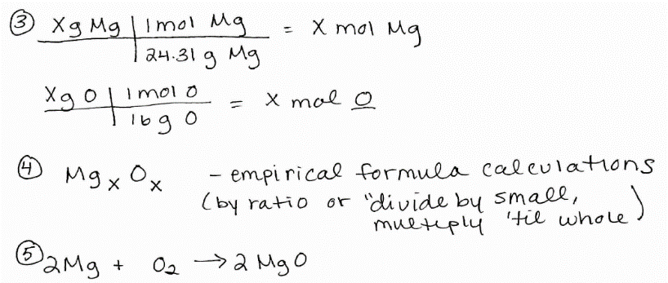  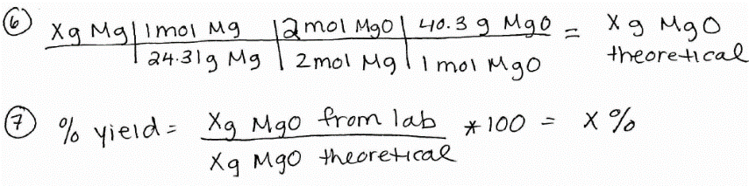
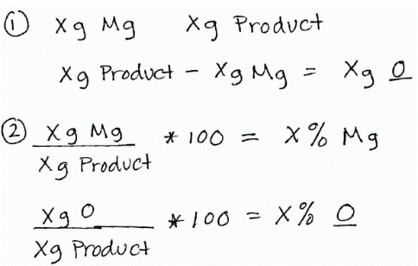
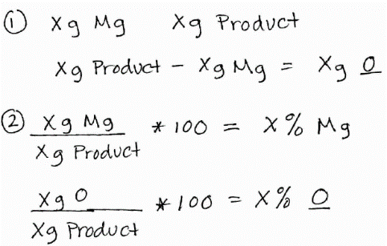
- Missing Questions:

Discussion Questions

General | 5
Obs/Data Tables | 15
Calcs. | 25
Discussion Qs | 15
Total | 60
- Questions copied from handout
- Questions not copied, but not paraphrased into your answer
- Incorrect  - 1  - 2  - 3A  - 3B  - 3C  - 4 | - Insufficient  - 1  - 2  - 3A  - 3B  - 3C  - 4 | - Not heating long enough or hot enough – means not all the Mg will react  - Contaminated – may produce other compounds  - A) Antoine Lovoisier – 1st to do it. Large and  expensive machine  B) Justus von Liebig – needed less sample and single  operator. CaCl2 absorbs H2O, KOH absorbs CO2,  measure by difference  C) Fritz Pregl – Nobel Prize for micro method  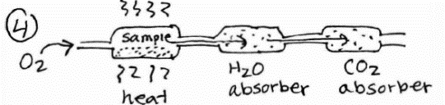
- Missing Questions:

