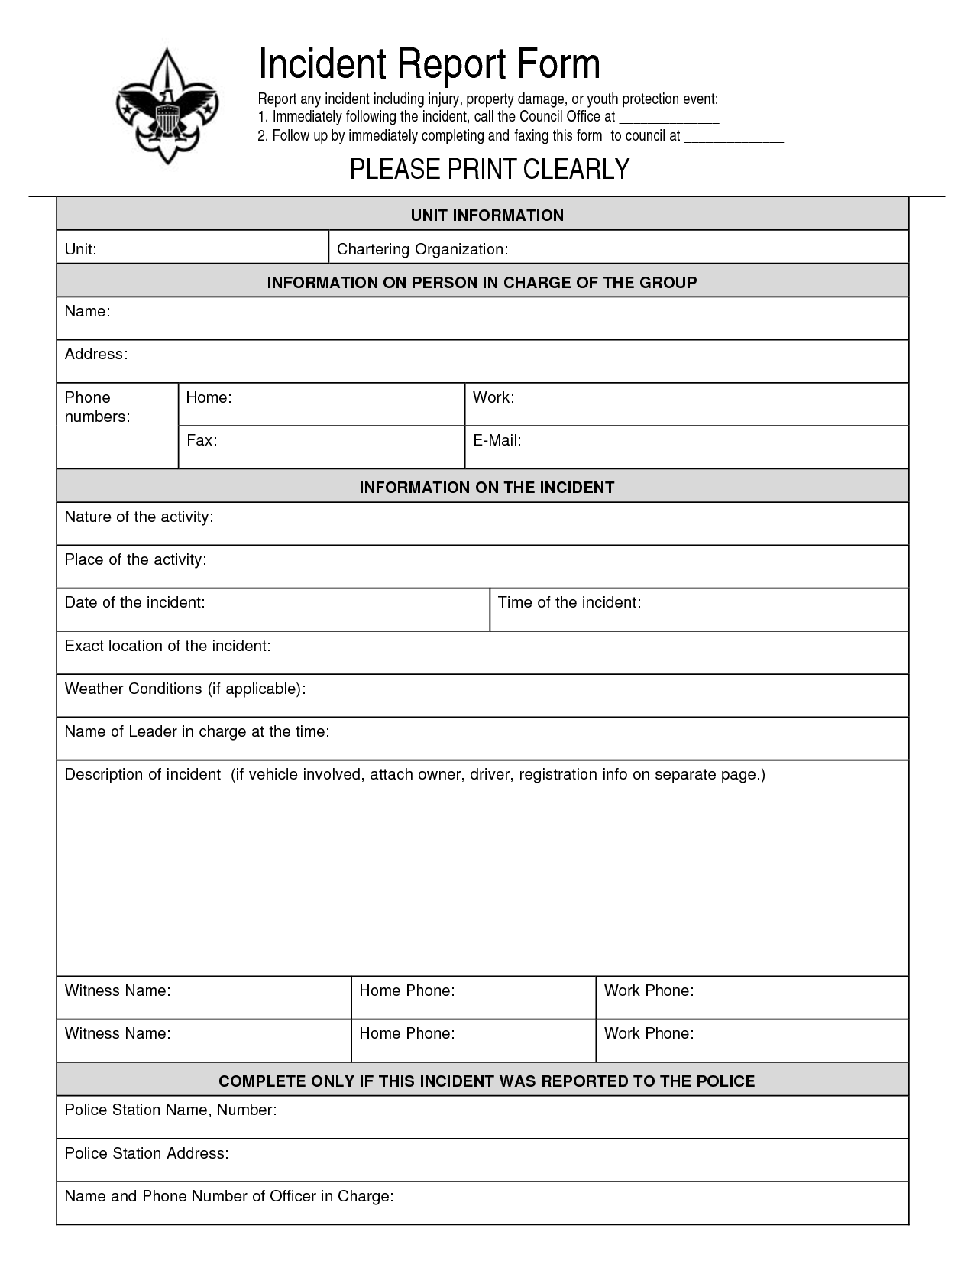

Officer Castle

Mark Johnson awoke at night to hearing his neighbor Shay Lemarck screaming at someone outside. Mr. Johnson looked out his bedroom window which faces the street and saw that Ms. Lemarck was engaged in an altercation with Tony DeMoy who lives in the house next to Ms. Lemarck. It appeared as Tony DeMoy was taking out his trash can late at night and Ms. Lemarck was unloading boxes from an unmarked delivery van. While on the phone with the officer, Mr. Johnson indicated that the altercation had ended and all parties went back into their respective homes. There was no officer dispatched, Mr. Johnson was told to call back if he felt assistance was needed at a later time.

**INFORMATION ON PERSON REPORTING THE INCIDENT**

Sidewalk in front of neighbor’s driveway

11:45 pm

October 21

5676 Monroe Street

Neighbor screaming at another neighbor

(444)333-1111

5678 Monroe Street

Mark Johnson

Incident Report

PLEASE PRINT CLEARLY OR TYPE