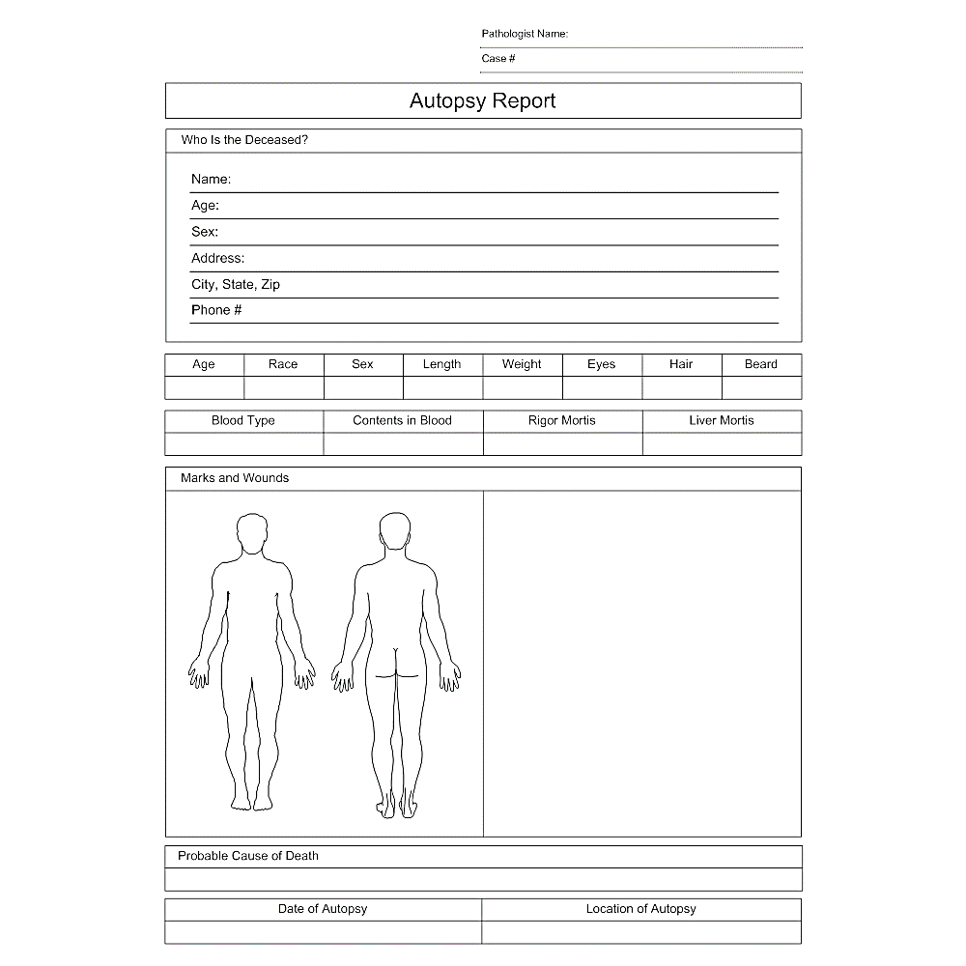

None observed on the outside of the body.

Lungs show upper respiratory tract irritation and blistering.

Toxicity from prolonged exposure to benzene.

Yes

Yes

Benzene

10/24

AB-

Hazel

Brown

Brown

195

6’ 0”

Male

White

45

(444)333-55555

Stars Hallow, CA 98989

5674 Monroe Street

Male

45 years

Tony DeMoy

Tony DeMoy

10550

Albert Robbins

CSI Coroner Building