**Regular stoich or limiting stoich?**

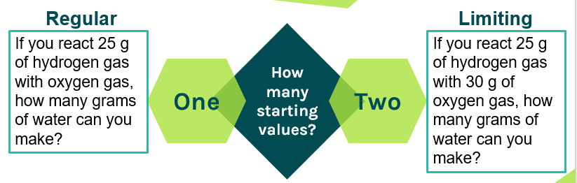

**Three main types of problems:**

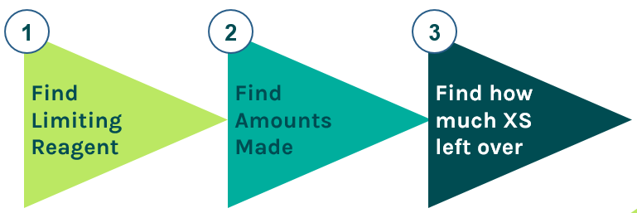

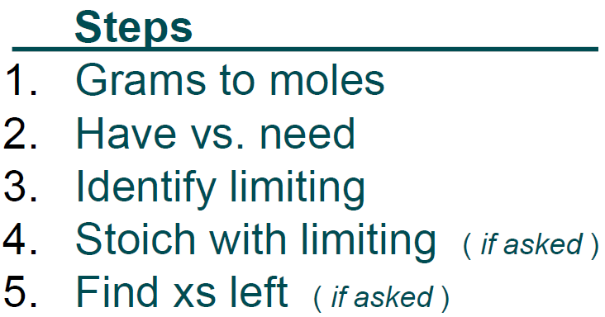

**Practice Problem #1:**

**If you reacted 150.0 g of K with 225 g of Br2, how may g of KBr can be made? How much excess reagent is left?  
 2K + Br2 🡪 2KBr**

**Practice Problem #2:**

**If you react 13.2 g of Fe with 6.34 g of O2, how may g of Fe2O3 are made? How many grams of excess are left?  
 4Fe + 3O2 🡪 2Fe2O3**

N-28

**Regular stoich or limiting stoich?**



**Three main types of problems:**





**Practice Problem #1:**

**If you reacted 150.0 g of K with 225 g of Br2, how may g of KBr can be made? How much excess reagent is left?  
 2K + Br2 🡪 2KBr**

**Practice Problem #2:**

**If you react 13.2 g of Fe with 6.34 g of O2, how may g of Fe2O3 are made? How many grams of excess are left?  
 4Fe + 3O2 🡪 2Fe2O3**

N-28