Total pressure of mixture  (3.0 mol He and 4.0 mol Ne) is 97.4 kPa. Find the partial pressure of each gas | Total pressure of mixture  (3.0 mol He and 4.0 mol Ne) is 97.4 kPa. Find the partial pressure of each gas | Total pressure of mixture  (3.0 mol He and 4.0 mol Ne) is 97.4 kPa. Find the partial pressure of each gas | Total pressure of mixture  (3.0 mol He and 4.0 mol Ne) is 97.4 kPa. Find the partial pressure of each gas
80.0 g each of He, Ne, and Ar are in a container. The total pressure is 780 mm Hg. Find each gas’s partial pressure. | 80.0 g each of He, Ne, and Ar are in a container. The total pressure is 780 mm Hg. Find each gas’s partial pressure. | 80.0 g each of He, Ne, and Ar are in a container. The total pressure is 780 mm Hg. Find each gas’s partial pressure. | 80.0 g each of He, Ne, and Ar are in a container. The total pressure is 780 mm Hg. Find each gas’s partial pressure.
Two 1.0 L containers, A and B, contain gases under 2.0 and 4.0 atm, respectively. Both gases are forced into Container C (^{w}/vol. 2.0 L). Find total pres. of mixture in C. | Two 1.0 L containers, A and B, contain gases under 2.0 and 4.0 atm, respectively. Both gases are forced into Container C (^{w}/vol. 2.0 L). Find total pres. of mixture in C. | Two 1.0 L containers, A and B, contain gases under 2.0 and 4.0 atm, respectively. Both gases are forced into Container C (^{w}/vol. 2.0 L). Find total pres. of mixture in C. | Two 1.0 L containers, A and B, contain gases under 2.0 and 4.0 atm, respectively. Both gases are forced into Container C (^{w}/vol. 2.0 L). Find total pres. of mixture in C.
Find total pressure of mixture in Container D.  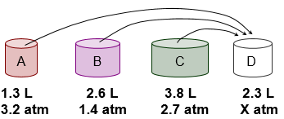 | Find total pressure of mixture in Container D. | Find total pressure of mixture in Container D. | Find total pressure of mixture in Container D.
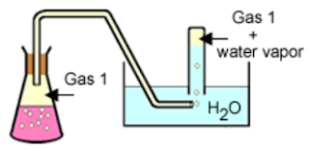

Hydrogen gas is collected over water at 22°C. Find the pressure of the dry gas if the atmospheric pressure is 708 mmHg. | Hydrogen gas is collected over water at 22°C. Find the pressure of the dry gas if the atmospheric pressure is 708 mmHg. | Hydrogen gas is collected over water at 22°C. Find the pressure of the dry gas if the atmospheric pressure is 708 mmHg. | Hydrogen gas is collected over water at 22°C. Find the pressure of the dry gas if the atmospheric pressure is 708 mmHg.
A gas is collected over water at a temp of 35°C while the barometric pressure is 0.976 atm. What is the partial pressure of the dry gas? | A gas is collected over water at a temp of 35°C while the barometric pressure is 0.976 atm. What is the partial pressure of the dry gas? | A gas is collected over water at a temp of 35°C while the barometric pressure is 0.976 atm. What is the partial pressure of the dry gas? | A gas is collected over water at a temp of 35°C while the barometric pressure is 0.976 atm. What is the partial pressure of the dry gas?
N-33
N-33
N-33
N-33

