Rate Expression  An equation you write based on the chemical equation.  - Reactants are used up, so concentration decreases, so they have a negative rate.  - Products are being made, so concentration increases, so they have a positive rate.  - In order to make all parts of the rate expression equal to each other you need to divide each component by its stoichiometric coefficient from the balanced rxn.  N₂ + 3 H₂ 2 NH₃  $$\frac{{- ∆[N}_{2}]}{∆t}= \frac{-1 ∆[H_{2}]}{3 ∆t}= \frac{1 {∆[NH}_{3}]}{2 ∆t}$$ | Rate Law  An equation that relates the change in concentration of reactants to the rate of reaction.  $$rate= {k [A]}^{x}{[B]}^{y} etc…$$
Rate Order
The exponents inside the rate law.

- The exponents are found experimentally.

- The exponents are the coefficients for the rate determining slow of the reaction mechanism…NOT the overall balanced equation! Usually we do not know what the slow step is so we have to find the exponents experimentally.

- If, and only if, the reaction is a single step reaction can you use the coefficients from the balanced reaction as the exponents because if it is a single step reaction that has to be the slow step!

- Use data charts of the reaction performed using different concentrations each time in order to determine the rate order. (See your notes on how to do that, too much for here!)

- Overall order is the sum of all the exponents. (x+y+etc…)

Average Rate
A rate that is found over a given time span, an average.

$$Average Rate= \frac{∆[X]}{∆t}= \frac{{[X]}_{final}- {[X]}_{initial}}{t_{final}-t_{initial}}$$

- Units would be $\frac{M}{s}$ which can also be written
as Ms⁻¹ or mol L⁻¹s⁻¹

- If given a chart or graph of data, you can just plug in the values to the above equation.

- If given the rate of appearance or disappearance of one substance in a chemical rxn, you can use the rate expression as an equation and can plug in the given rate in order to solve for the rate of appearance or disappearance of another substance in the rxn. Be careful of coefficients when doing the calculations!
Instantaneous Rate  A rate that is found for one exact moment in time, uses the slope of a tangent line in order to find the rate at that exact point in time.  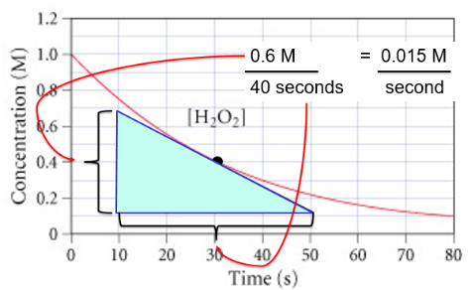  - Remember that slope is “rise over run”  - Make sure your tangent line is drawn with equal angles on both sides!  - These will typically be rough estimates for this class.  - Pick data points that are convenient when finding rise/run! | Rate Constant  A constant that allows us to relate concentrations of reactants to the overall rate of reaction. Rate Constant = k  - Changes with change in temperature or addition of a catalyst. Change in concentrations do NOT change k value, because that does not change the mechanism of the rate determining step of the reaction.  - Units of k vary based on the overall order of the reaction. They need to be whatever necessary so the rate units end up being M/s  - Once the rate law is written with the orders determined, you can pick a trial and plug in data in order to algebraically solve for k. It is always experimentally determined.
R-41

