|  |  |  |  |
| --- | --- | --- | --- |
|  | **Alpha Particle Emission** | **Beta Particle Emission** | **Gamma Ray Emission** |
| **Symbol** |  |  |  |
| **Mass** | Heavy | Light | No mass |
| **How it changes the nucleus** | * Decreases the mass number by 4 * Decreases the atomic number by 2 | * Converts a neutron into a proton * Increases the atomic number by 1 | * No change to nucleus numbers * Release of energy |
| **Penetration** | Low | Medium | High |
| **Protection provided by** | Skin | Paper, clothing | Lead, thick concrete |
| **Danger** | Low | Medium | High |

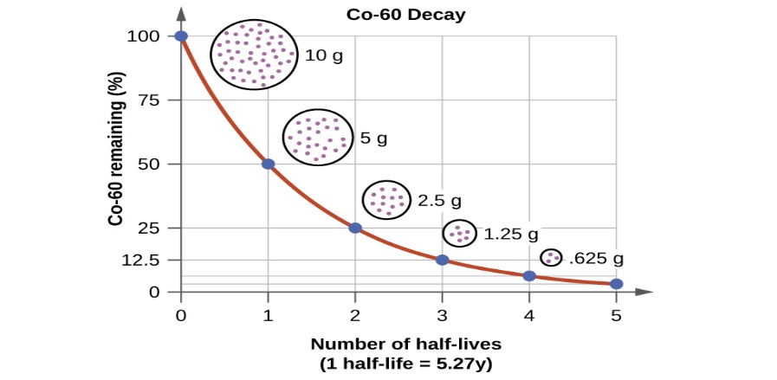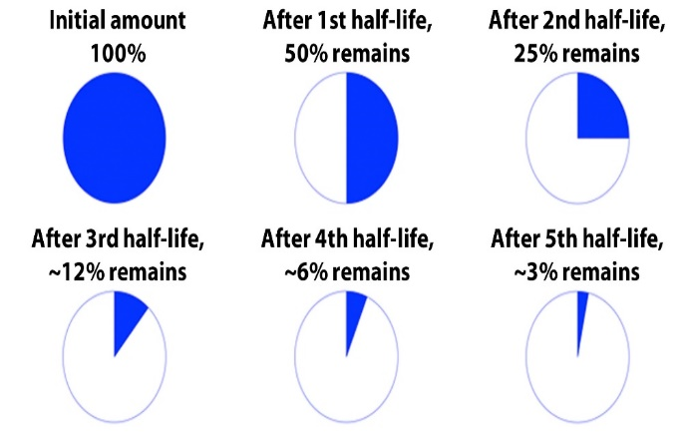

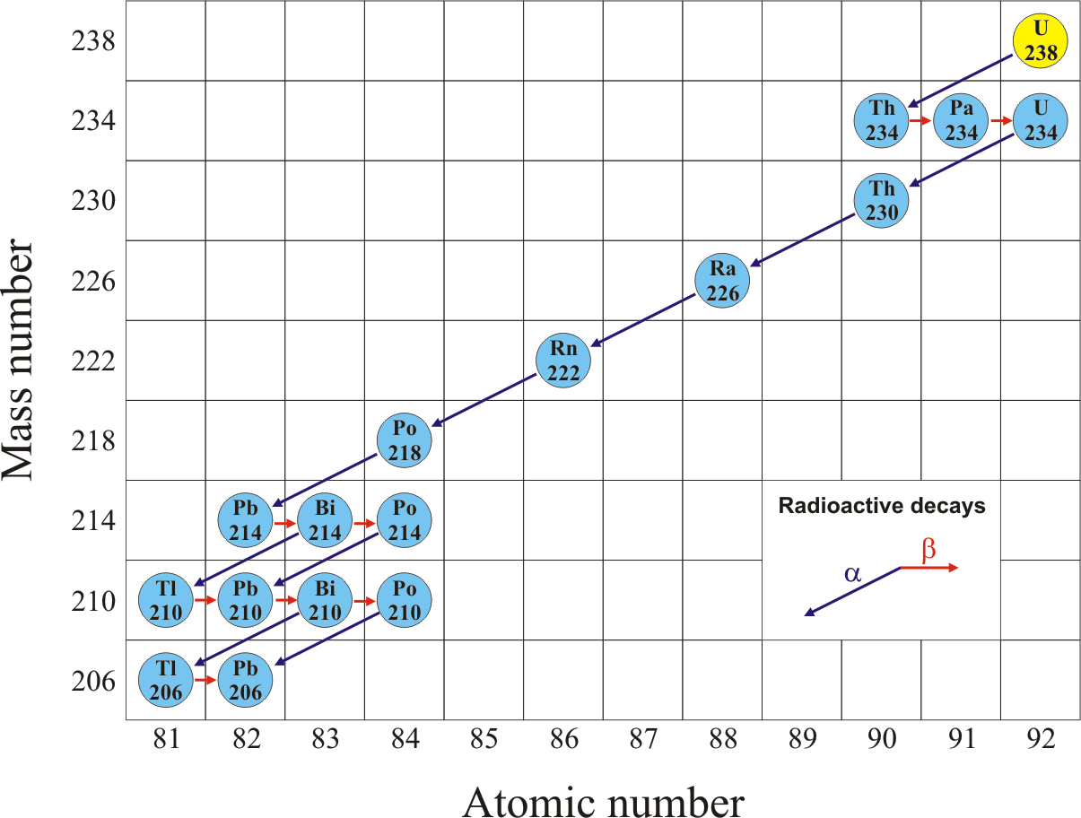

**R-14**

**Half Life Equation**

$A_{E}= A_{s} ×{0.5}^{n}$

AE = amount ending   
AS = amount starting   
n = number of half lives

**# of Half Lives**

$$n= \frac{t}{h}$$

n = number of half-lives  
t = time that has passed  
h = length of a half life

**% still radioactive or % decayed**

$$\%_{still r.a.}= \frac{A_{E}}{A_{S}} ×100$$

AE = amount ending   
AS = amount starting   
n = number of half lives

$\%_{still r.a.}= {0.5}^{n} ×100$

$\%_{decayed}= 100- \%_{still r.a. }$

**Solving for t, or h**

$$log\left(\frac{A_{E}}{A_{S}}\right)= n ×log\left(0.5\right)$$

*Same as this version:*

$$log\left(\frac{A_{E}}{A_{S}}\right)= \frac{t}{h} ×log\left(0.5\right)$$

Simply isolate the variable you are trying to solve for

$$t=\frac{h ×log\left(\frac{A_{E}}{A_{S}}\right)}{log\left(0.5\right)}$$

$$h=\frac{t ×log\left(0.5\right)}{log\left(\frac{A_{E}}{A_{S}}\right)}$$