Orbital Diagram

R-15

Order of Orbital Filling

1s² 2s² 2p⁶ 3s² 3p⁶ 4s² 3d¹⁰ 4p⁶ 5s² 4d¹⁰ 5p⁶ 6s² 4f¹⁴ 5d¹⁰ 6p⁶ 7s² 5f¹⁴ 6d¹⁰ 7p⁶

Remember! We take e⁻’ s out in a different order than we put them into orbitals!

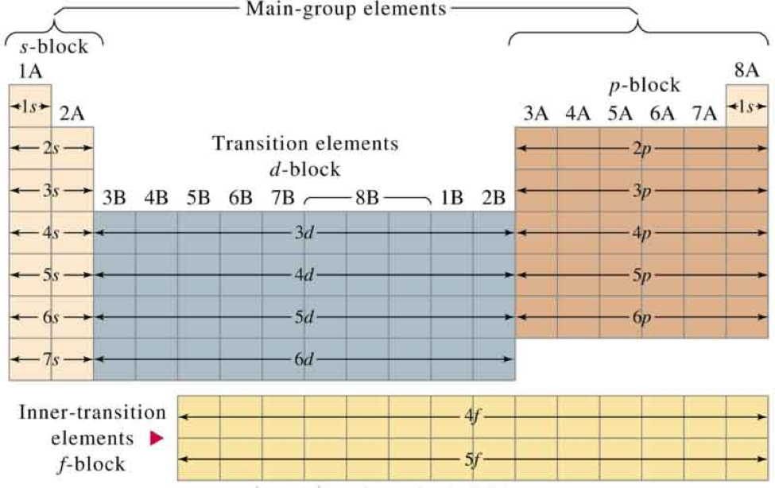
Back to d-block!
