**Periods** (rows) **🡪 Mendeleev –** Organized PT based on atomic masses & properties (almost right…)

**Groups** (columns) **↑ Moseley –** Organized PT based on atomic numbers (the way we do it now!)

**Three classes of elements:** Metals, non-metals, metalloids/semi-metals

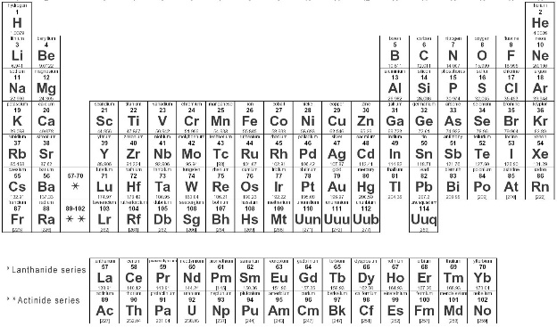

 ***Use this link to color code each class of   
 element on the periodic table to the left.*** <https://tinyurl.com/46a3armf>

**Some videos about the structure & creation of the periodic table**

* <https://tinyurl.com/n4o9dns>
* <https://tinyurl.com/y7jtlkbw>
* <https://tinyurl.com/abq96op>
* <https://tinyurl.com/q2z47cl>

***Make a key here:***

󠇯 metals

󠇯 non-metals

󠇯 metalloids/

semi-metals

**Metal Properties:**

|  |  |
| --- | --- |
| **Chemical Prop.** | **Physical Prop.** |
| Few electrons in VALENCE shell (outer shell) | Ductile  Malleable |
| Lose electrons easily | Good conductors |
| POSITIVE charge like Ca2+ | Shiny |
| Make Cations | Solid at room temp |

**Non-metal Properties:**

|  |  |
| --- | --- |
| **Chemical Prop.** | **Physical Prop.** |
| Almost full, or totally full valence shell | NOT Ductile  NOT malleable |
| Tend to gain electrons | BAD conductors |
| NEGATIVE charge like N3- | Mostly solid |
| Make ANIONS | Some are gas at room temp |

**Semi-metal Properties:**

|  |  |
| --- | --- |
| **Chemical Prop.** | **Physical Prop.** |
| Most have half full valence shell | Have properties of metals AND non-metals |
| Make anions OR cations depending on their environment | No way to know which properties of each |

**TURN OVER AND COLOR CODE THE BACK TOO! USE THE SAME LINK AS THE TOP.**

**Things in the same period have:**

Increasing atomic # and mass L→R

Same number of energy levels

Period 1 has 1 level

Period 2 has 2 levels etc…

**Things in the same group have:**

Increasing atomic # and mass ↓

Same number of valence electrons

Exceptions: d and f block

Similar physical and chemical properties

b/c they have same # of valence e-s

**Valence Electrons:**

Outer electrons

Matches the “A” column number   
1A has 1 v.e-, 2A has 2v.e-, etc.

d and f blocks don’t follow rules

**Shielding and Zeff:**

Outer electrons have trouble “seeing” the protons in the nucleus – the nucleus is “shielded” by the electrons. You can calculate how much “shielding” there is by calculating the “Effective Nuclear Charge”

Zeff = Z – S

*Zeff = effective nuclear charge  
Z = atomic #  
S = all non-valence electrons*

**R-17**

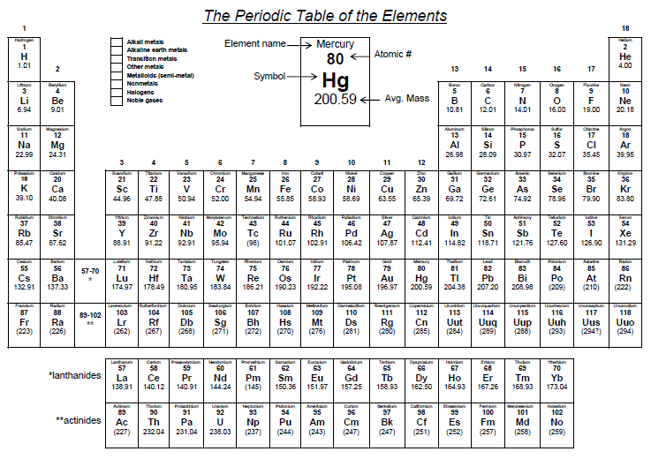

* Alkali metals
* Alkaline earth metals
* Transition metals
* Rare earth metals
* Metalloids (semi-metals)
* Other metals
* Non-metals
* Halogens
* Noble Gases