**DVHS Chemistry**

**Types of Bonds Reader**

**Directions:**   
Read this page and take notes and/or annotate it. We will not be doing a traditional lecture on this material because it is mostly review material. There is potentially information in here you may not be familiar with. If you come across anything you do not understand you need to ask about it! At the end there are questions to check that you were able to follow and grasp the material talked about here. These are selections of reading by various people, credit given when possible.

**Types of Bonds –** *by Janet Rae-Dupree, Pat DuPree. Edited to suit our purposes here.*

Atoms tend to arrange themselves in the most stable patterns possible, which means they have a tendency to complete or fill their valence shells. They join with other atoms in order to do that. The force that holds atoms together as “molecules” or “compounds” is referred to as a *chemical bond.* There are three main types of bonds, and they each may have some sub categories that are more specific.

**Ionic Bond –** *by Janet Rae-Dupree, Pat DuPree.   
Edited to suit our purposes here.*

Ionic bonding involves the transfer of electrons. One atom gains one or more electrons, while another atom loses one or more electrons. The atom that lost an electron carries a negative charge (anion), and the atom that lost an electron carries a positive charge (cation). Because opposite charges attract, the atoms bond together to form a compound. The electrostatic attraction is the “bond.” Ionic bonds are formed when one atom has a low ionization energy (cation, metal) and another atom has a high electron affinity (anion, nonmetal). That essentially results in needing a metal and a non-metal to form an ionic bond.

*Examples: NaBr – sodium is a metal, bromine is a   
 nonmetal. Na turn into Na+ and gives its   
 electron to Br which turns into Br-*

*MgF2 – magnesium is a metal, fluorine is a nonmetal. Mg turns into Mg2+ and gives two electrons to the fluorine atoms. Each fluorine turns into F- so you need two fluorine atoms in order to balance out the +2 charge of the magnesium.*

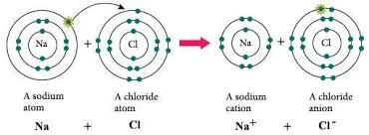

**Covalent Bond –** *by Janet Rae-Dupree, Pat DuPree.   
Edited to suit our purposes here.*

Covalent Bonds involve the sharing of electrons between two atoms. The pair of shared electrons holds the atoms close together and this sharing of electrons is the bond. Covalent bonds form when there is not an atom with a sufficiently low ionization energy to simply “give up” the electron, and the other atom does not have a sufficiently high electronegativity to “steal” the electron completely. That essentially results in needing two (or more) nonmetals to form the bond. One thing to note is that when a covalent bond is formed, neither atom truly has a complete valence shell. It “feels” like it has a full shell due to the sharing, but it doesn’t completely “own” those electrons.

*Examples:* *H2O – each hydrogen and each oxygen   
 “donate” an electron to a shared bon. Both   
 hydrogen and oxygen are nonmetals. They   
 are not strong enough to steal the electron   
 completely from the other atom.*

*Cl2 – Each chlorine only has 7 valence   
electrons. If they each “donate” one to share then they are tricked into thinking they each have 8 valence electrons.*

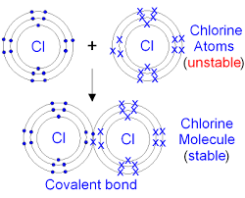

Nonmetals can donate one electron each to form a single bond (2 electrons being shared), or they can each donate two electrons to form a double bond (4 electrons being shared), or they can each donate three electrons to form a triple bond (6 electrons being shared).

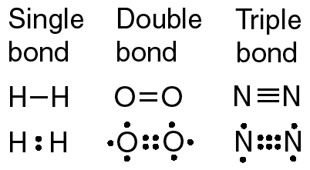

**Metallic Bond –**

Metallic bonds form when one or more types of metals are together. The vacant p and/or d orbitals in the metal atoms’ outer energy levels overlap, and allow outer valence electrons to move freely through the metal. The valence electrons basically “detach” and float around as a “sea of electrons.” We say that the electrons are “delocalized” and no longer belong to any particular atom. This sea of electrons effect allows the electrons to flow through the material – this is how electricity can be conducted through something like a metal wire. All the delocalized electrons are flowing from one end of the wire to the other because they are not attached to their nuclei anymore. If you have more than one type of metal atom present it is called an “alloy.” These metallic mixtures can form unique properties that can be useful.

*Example: Cu – note: you do not need to include a   
 subscript for metallic materials. It is not   
 practical to tell someone how many atoms are   
 present in a chunk of metal. Because the   
 electrons essentially belong to every atom, it   
 isn’t really a molecule or compound in the   
 traditional sense. If you just see a metallic   
 element listed by itself you can assume there   
 are lots present and it is a metallic bond – like   
 Mg, Ag, Cu, Fe*

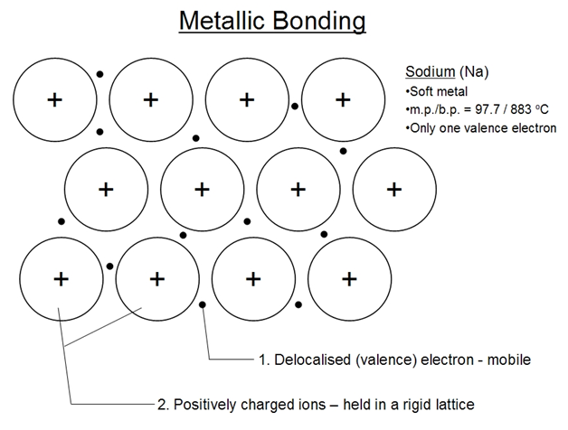

delocalized