**DVHS Chemistry   
Nomenclature Reader**

**Will be stamped and count for points towards your binder check grade!**

**Name: Period: Seat#:**

**Directions:**   
Read this page and take notes and/or annotate it. We will not be doing a traditional lecture on this material because it is mostly review material. There is potentially information in here you may not be familiar with. If you come across anything you do not understand you need to ask about it! At the end there are questions to check that you were able to follow and grasp the material talked about here. These are selections of reading by various people, credit given when possible.

**Nomenclature –** *by the International Union of Pure and Applied Chemistry**Edited to suit our purposes here.*

A system of rules for naming chemical compounds. The International Union of Pure and Applied Chemistry (IUPAC) devised the system for naming compounds in order to ensure uniformity, consistency, and avoid ambiguity.

**Ionic Compounds**

For simple binary ionic compounds (ionic compounds composed of one kind of metal and one kind of nonmetal) the cation name comes first and then the anion. Simple *cations* take the name of their element, for example, the name for K+ would be potassium, and the name for Zn2+ would be Zinc. Elements that form two or more ions need a roman numeral to denote their charge. For example, many transition metals can form ions with different charges, although they will always form cations. For example, copper can form Cu+ which would be named copper (I), or it can form Cu2+, which would be named copper (II).

Simple *anions* use the base name of the element, but end in *–ide.* For example, F- would be named fluoride, and I- would be named iodide.

Put the name of the cation and anion together to name the ionic compound. For example, NaCl is named sodium chloride. ZnS is named Zinc sulfide.

Compounds made with polyatomic ions do not change their anion name – keep the special polyatomic names for both cation and anion! NH4I is named Ammonium Iodide, Li2CO3 is named Lithium carbonate.

*Note: Some stable ions do not have noble gas configurations!* *Polyatomic Ions (ions with several types of atoms have names that will need to be memorized.* *Check your Common Ions table for the ions you will be required to memorize.*

**R-21**

**Naming Covalent Molecules –** *by Eden Francis. Edited to suit our purposes here.*

Covalent molecules use a different system for nomenclature. Simple covalent molecules are generally named by using **Greek prefixes** to indicate how many atoms of each element are shown in the formula and the ending of the last element is changed to **-ide**. The **mono-** prefix is usually not used for the first element in the formula. Some double vowels are omitted to help with ease of pronouncing the molecule name. The "o" and "a" endings of these prefixes commonly are dropped when they are attached to "oxide." See the table below for the Greek prefixes you will need to memorize.

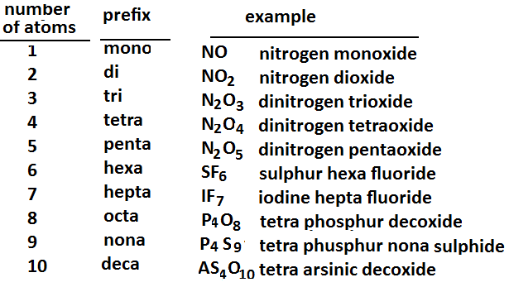

**Diatomic Molecules**

A molecule composed of only two atoms is said to be diatomic. There are several diatomic molecules made of the same element that you will need to memorize. Luckily, there is a mnemonic device for this. ***H***orses ***N***eed ***O***ats ***F***or ***Cl***ear ***Br***own Eyes ***(I)*** will help you remember that H2, N2, O2, F2, Cl2, Br2, and I2 are all diatomic molecules. Another mnemonic is “H-7” which reminds you that there are seven diatomic elements, they make the shape of a seven on the periodic table, starting with N, and that Hydrogen is one of the diatomic elements.

**Practice –** *We will review these names in class!*

1. **CO**
2. **CO2**
3. **S4N2**
4. **N2O6**
5. **PF3**