Gas Laws Summary Chart

P = Pressure V = Volume T = Temperature n = # moles Subscript 1 = initial/starting value Subscript 2 = final/ending value

 | Boyle’s Law | Charles’ Law | Gay-Lussac Law | Avogadro’s Law | Combined Law
Variables | Pressure,  Volume | Volume,  Temperature | Pressure,  Temperature | Moles,  Volume | Pressure, Volume, Temperature
Constant | Temperature,  # moles | Pressure,  # moles | Volume,  # moles | Pressure,  Temperature | # moles
Equation | $$P_{1}V_{1}= P_{2}V_{2}$$ | $$\frac{V_{1}}{T_{1}}= \frac{V_{2}}{T_{2}}$$ | $$\frac{P_{1}}{T_{1}}= \frac{P_{2}}{T_{2}}$$ | $$\frac{V_{1}}{n_{1}}= \frac{V_{2}}{n_{2}}$$ | $$\frac{{P_{1}V}_{1}}{T_{1}}= \frac{{P_{2}V}_{2}}{T_{2}}$$
Type of Relationship | Indirect  ↑ P= ↓ V  ↓ P= ↑ V | Direct  ↑ T = V ↑  ↓ T = V ↓ | Direct  ↑ T = P ↑  ↓ T = P ↓ | Direct  ↑ n = V ↑  ↓ n = V ↓ | ---
Law Stated in Words | The volume of a fixed amount of gas varies inversely with pressure if temperature is kept constant. | The volume of a fixed amount of gas is directly proportional to its Kelvin temperature if the pressure is kept constant | The pressure of a fixed amount of gas is directly proportional to the Kelvin temperature if the volume is kept constant | The volume of a gas is directly proportional to the number of moles present in the container if the temperature and pressure are kept constant. | Boyle’s, Charles’ and Gay-Lussac Laws combine the relationship between pressure, volume, and temperature
Real Life Example | Putting oxygen gas under high pressure will compress it and shrink the volume so it can fit into an oxygen tank to use while scuba diving. | A hot air balloon works by heating the gas inside the balloon causing it to expand. | A can of hairspray in a hot car will cause the gas particles to move faster which increases collisions, so the pressure increases, risking exploding the can. | When blowing up a balloon, you add more moles of gas and the volume increases. | A bag of chips is brought from sea level to the top of Mount Everest. As it gets closer to the summit the atmospheric pressure and temperature change which causes the volume of the bag to change also.
Graphical Depiction  R-35 | 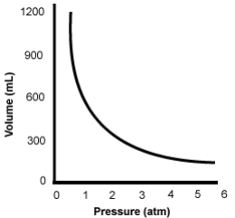 | 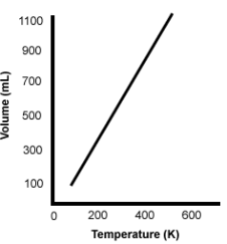 | 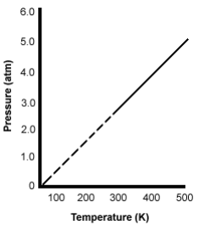 |  | ---

 | Dalton’s Law of Partial Pressures | Ideal Gas Law
Equation | $$P_{total}=nP_{1}+nP_{2}+ nP_{3}…$$  $${P_{atm} or P}_{total}= P_{gas}- P_{vapor}$$ | $$PV=nRT$$
Law Stated in Words | At constant volume and temperature, the total pressure exerted by a mixture of gases is equal to the sum of the pressures of each gas.  When collecting a gas over a liquid (usually water) you need to subtract how much pressure is coming from the liquid’s vapor in order to determine what the pressure of the gas you are interested in is. | The Ideal Gas Law relates the pressure, temperature, volume and moles of a gas through the gas constant “R.”  The ideal gas law reduces to the other gas laws when you start holding different variables constant.  The Ideal Gas Law can also relate density and molar mass with the gas constant “R.”

Water Vapor Pressure at Various Temperatures for
Dalton’s Partial Pressure Problems - Collecting a Gas Over Water
Temperature (ºC) | Pressure (mmHg) | Temperature (ºC) | Pressure (mmHg) | Temperature (ºC) | Pressure (mmHg) | Temperature (ºC) | Pressure (mmHg)
0.0 | 4.6 | 21.0 | 18.6 | 27.0 | 26.7 | 50.0 | 92.5
5.0 | 6.5 | 22.0 | 19.8 | 28.0 | 28.3 | 60.0 | 149.4
10.0 | 9.2 | 23.0 | 21.1 | 29.0 | 30.0 | 70.0 | 233.7
15.0 | 12.8 | 24.0 | 22.4 | 30.0 | 31.8 | 80.0 | 355.1
18.0 | 15.5 | 25.0 | 23.8 | 35.0 | 42.2 | 90.0 | 525.8
20.0 | 17.5 | 26.0 | 25.2 | 40.0 | 55.3 | 100.0 | 760.0

Finding Molar Mass Using Ideal Gas Law | $n= \frac{mass}{molar mass}$ So rearrange ideal gas equation… $PV= \frac{mRT}{M}$ therefore… $M= \frac{mRT}{PV}$ (m = mass, M = Molar Mass)
Finding Density Using Ideal Gas Law | $D= \frac{m}{V}$ and $M= \frac{mRT}{PV }$ Substituting D for $\frac{m}{V}$ you end up getting $M= \frac{DRT}{P}$ then rearrange to solve for D you get… $D= \frac{MP}{RT}$

Key Info | STP = Standard Temperature and Pressure  1 atm and 0°C (273 K)  Molar Volume at STP = 22.4L/1mol | Ideal Gas Constant = R Pick the right R value!  0.0821 L • atm = 8.31 L • kPa = 62.4 L • mmHg You can always change  mol • K mol • K mol • K the pressure units and  use your favorite R value!
 | K = 273 + °C  Change ALL temperatures to Kelvin!!!! | 1 atm = 1.01325 x 10⁵ Pa = 101.325 kPa = 760 mmHg = 760 torr = 14.7 psi

