SET #1  Questions #1 - 8 |  | SET #2  Questions #9 - 16
Answer #1  Strontium Oxide |  | Answer #9  Single replacement/single displacement
Answer #2  421.61 g/mol |  | Answer #10  CI₂
Answer #3  Sea of electrons, delocalized electrons etc. |  | Answer #11  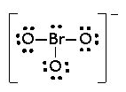
Answer #4  Covalent bond |  | Answer #12  tetrahedral
Answer #5  2 mol O₂ : 1 mol CH₄ |  | Answer #13  68.15 g/mol
Answer #6  Hydrogen bonding  Remember H-NOF! |  | Answer #14  trigonal pyramidal
Answer #7  Metallic < Ionic Lattice  < Network Covalent |  | Answer #15  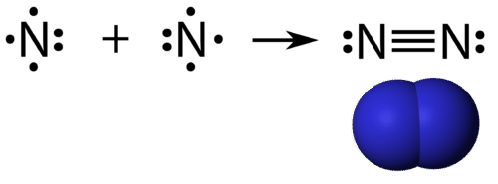
Answer#8  Cu(SO₄)₂ |  | Answer #16  Combustion!
SET #3  Questions #17 - 25 |  | SET #4  Questions #26 - 33
Answer #17  AlPO₄ + 3Rb(NO₂) →  Al(NO₂)₃ + Rb₃(PO₄) |  | Answer #26  Na₂ CO₃
Answer #18  Unequally! |  | Answer #27  106g/mol
Answer #19  10 mol ZnO!  Same molar ratio! |  | Answer #28  Fe₂(SO₄)₃=  400.1 g/mole
Answer #20  31.1g ZnO |  | Answer #29  0.111 moles  Fe₂(SO₄)₃
Answer #21  H₂ F₂ Cl₂ Br₂  I₂ O₂ N₂ |  | Answer #30  1087.7g  KCl
Answer #22  77.98 g/mol |  | Answer #31  1592.68 g  Fe₂(CO₃)₃
Answer #23  L of A→molA→mol B→L of B  76L H₂O |  | Answer #32  Double displacement.
Answer #24  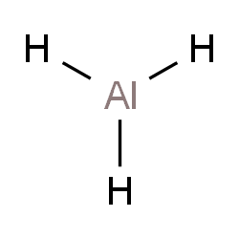 |  | Answer #33  3CuBr₂ + 2AlCl₃ → 3CuCl₂ +2AlBr₃
Answer #25
2 mole TNT : 7 mole CO
SET #5  Questions #34 - 41 |  | SET #6  Questions #42 - 49
Answer #34  0.103 moles |  | Answer #42  0.99g
Answer #35  1 mole Fe₂(SO₄)₃ =  3 moles Na₂SO₄ |  | Answer #43  8.2 mol
Answer #36  30 moles Na₂SO₄ |  | Answer #44  1.23 x 10²⁴  molecules
Answer #37  2H₂ + O₂ → 2H₂O  0.94 moles water |  | Answer #45  5.44 x 10⁻⁵  mol B
Answer #38  - Production of heat and light  - Production of a gas  - Formation of a precipitate  - Change in color |  | Answer #46  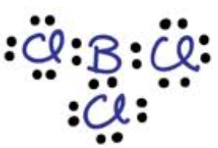Trigonal Planar
Answer #39  2Na + Cl₂ → 2NaCl  1 mole Cl₂ |  | Answer #47  Valence  electrons
Answer #40  2NaCl+Ba→BaCl₂+2Na  39.32 g Na |  | Answer #48  Gain 3 electrons
Answer #41  19.52L  F₂ |  | Answer #49  26 ve-
SET #7  Questions #50 - 58 |  | SET #8  Questions #59 - 66
Answer #50  Ionic, covalent,  covalent, covalent,  ionic |  | Answer #59  1 lone pair
Answer #51  Mono, di, tri, tetra,  penta, hexa, hepta,  octa, nona, deca |  | Answer #60  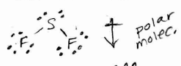
Answer #52  Dicarbon  hexahhydride |  | Answer #61  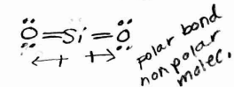
Answer #53  Silver oxide |  | Answer #62  CHCl₃ is more polar because greater electroneg. difference between atoms than in CHBr₃
Answer #54  Copper (III) Nitrite |  | Answer #63  London forces
Answer #55  Sulfur hexoxide |  | Answer #64  Dipole-Dipole  (yes H is there, but no H-NOF:)
Answer #56  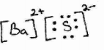 |  | Answer #65  Network Covalent
Answer #57  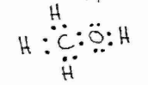 |  | Answer #66  4
Answer #58
0 lone pairs

