|  |  |  |
| --- | --- | --- |
| 1. | Express 1570000 in scientific notation. | |
| A) | 4.62  10–8 |
| B) | 1.57  10–6 |
| C) | 1.57  106 |
| D) | 157  106 |
| E) | 157  104 |

|  |  |  |
| --- | --- | --- |
| 2. | Express 30514000 in scientific notation. | |
| A) | 3  107 |
| B) | 3.0514  107 |
| C) | 305  107 |
| D) | 30514  103 |
| E) | 305140  107 |

|  |  |  |
| --- | --- | --- |
| 3. | The number 0.005899 expressed in scientific notation is | |
| A) | 5.90  103 |
| B) | 5.899  103 |
| C) | 5.90  10–3 |
| D) | 5.899  10–3 |
| E) | 5899  10–6 |

|  |  |  |
| --- | --- | --- |
| 4. | Express the number 0.00346 in scientific notation. | |
| A) | 3.46  10–3 |
| B) | 3.46  103 |
| C) | 0.346  10–3 |
| D) | 346  10–5 |
| E) | none of these |

|  |  |  |
| --- | --- | --- |
| 5. | 1.5 kilogram(s) contains this many grams: | |
| A) | 1.5 x 102 |
| B) | 1.5 x 103 |
| C) | 15 |
| D) | 0.15 |
| E) | 1.5 x 10-3 |

|  |  |  |
| --- | --- | --- |
| 6. | The volume of a helium balloon is 2.4 L. What is this volume in cm3? (1 L = 1 dm3) | |
| A) | 24. cm3 |
| B) | 2.4  103 cm3 |
| C) | 2.4  102 cm3 |
| D) | 0.24 cm3 |
| E) | 2.4  104 cm3 |

|  |  |  |
| --- | --- | --- |
| 7. | The element curium (*Z* = 242, *A* = 96) can be produced by positive-ion bombardment when an alpha particle collides with which of the following nuclei? Recall that a neutron is also a product of this bombardment. | |
| A) |  |
| B) |  |
| C) |  |
| D) |  |
| E) |  |

|  |  |  |
| --- | --- | --- |
| 8. | The iodine-131 nuclide has a half-life of 8.0 days. If you originally have a 623-g sample, after 2.0 months you will have (Ignore sig figs for this problem.) | |
| A) | 46 g |
| B) | 54 g |
| C) | 120 g |
| D) | 3.4 g |
| E) | less than 1 g |

**S-7\***

|  |  |  |
| --- | --- | --- |
| 9. | A radioactive element has a half-life of 2.00 weeks. What % of the original sample is left after 19.5 days? | |
| A) | 38.1% |
| B) | 60.8% |
| C) | 61.9% |
| D) | 1.39% |
| E) | none of these |

|  |  |  |
| --- | --- | --- |
| 10. | A sample of a radioactive element decays to 27.5% of its original amount of radioactive nuclides in 15 years. What is the half-life of this radioactive element? | |
| A) | 32. years |
| B) | 2.5 years |
| C) | 8.1 years |
| D) | 91.9 years |
| E) | 8.6 years |

|  |  |  |
| --- | --- | --- |
| 11. | A radioactive element has a half-life of 1.20 years. What % of the original sample is left after 168.1 days? | |
| A) | 23.4% |
| B) | 76.6% |
| C) | 38.3% |
| D) | 25.5% |
| E) | 16.4% |

|  |  |  |
| --- | --- | --- |
| 12. | The measurement 3.3 x103 g also could be written as | |
| A) | 3.3 g |
| B) | 3.3 mg |
| C) | 3.3 pg |
| D) | 3.3 kg |
| E) | 3.3 dg |

|  |  |  |
| --- | --- | --- |
| 13. | Which metric prefix is used to designate 1000? | |
| A) | m |
| B) | M |
| C) | k |
| D) | c |
| E) | d |

|  |  |  |
| --- | --- | --- |
| 14. | Which of the following is an SI unit for expressing the mass of a block of Au? | |
| A) | m |
| B) | g |
| C) | L |
| D) | pound |

|  |  |  |
| --- | --- | --- |
| 17. | You take 20.0 mL of water from a graduated cylinder and add it to the beaker of water below. What is the new volume of water in the beaker? | |
| A) | 40 mL |
| B) | 40. mL |
| C) | 35 mL |
| D) | 35.0 mL |
| E) | 25.0 mL |

|  |  |  |
| --- | --- | --- |
| 23. | Water has a density of 1.0 g/mL. Which of these objects will float in water?  Object I: mass = 50.0 g; volume = 60.8 mL  Object II: mass = 65.2 g; volume = 42.1 mL  Object III: mass = 100.0 g; volume = 20.0 mL | |
| A) | I only |
| B) | I, III |
| C) | II only |
| D) | II, III |
| E) | III only |

|  |  |  |
| --- | --- | --- |
| 24. | Calculate the mass of a rectangular solid that has a density of 3.87 g/cm3 and measures 2.50 cm by 1.80 cm by 3.00 cm. | |
| A) | 3.49 g |
| B) | 52.2 g |
| C) | 9.68 g |
| D) | 28.3 g |
| E) | 55.2 g |

|  |  |  |
| --- | --- | --- |
| 25. | Find the volume of an object that has a density of 3.14 g/mL and a mass of 55.0 g. | |
| A) | 17.5 mL |
| B) | 5.71 x 10–2 mL |
| C) | 173 mL |
| D) | 1.75 x 10–2 mL |
| E) | 1.73 x 105 mL |

|  |  |  |
| --- | --- | --- |
| 26. | An object has a mass of 40.1 g and occupies a volume of 6.09 mL. The density of this object is | |
| A) | 244 g/mL |
| B) | 0.152 g/mL |
| C) | 6.58 g/mL |
| D) | too low to measure |
| E) | 40.1 g/mL |

|  |  |  |
| --- | --- | --- |
| 27. | The density of an object that has a mass of 4.48 g and occupies a volume of 1.20 mL equals | |
| A) | 4.48 g/mL |
| B) | 1.20 g/mL |
| C) | 3.73 g/mL |
| D) | 0.27 g/mL |
| E) | 5.38 g/mL |

|  |  |  |
| --- | --- | --- |
| 28. | A freighter carrying a cargo of uranium hexafluoride sank in the English Channel late August 1984. The cargo of uranium hexafluoride weighed 2.249 x 108 kg and was contained in 30 drums, each having a volume of 1.62 x 106 L. What is the density (g / mL) of uranium hexafluoride? | |
| A) | 1.39 g / mL |
| B) | 4.63 g / mL |
| C) | 2.25 g / mL |
| D) | 0.216 g / mL |
| E) | 46.3 g / mL |

|  |  |  |
| --- | --- | --- |
| 31. | The half-life of a radioactive nuclide is | |
| A) | that period of time in which 25% of the original number of atoms undergoes radioactive decay. |
| B) | the time at which the isotope becomes nonradioactive. |
| C) | that period of time in which 50% of the original number of atoms undergoes radioactive decay. |
| D) | the period of time it takes to reduce the radioactivity by 100%. |
| E) | none of the above |

|  |  |  |
| --- | --- | --- |
| 33. | The state of matter for an object that has neither definite shape nor definite volume is | |
| A) | solid |
| B) | liquid |
| C) | gaseous |
| D) | elemental |
| E) | mixed |

|  |  |  |
| --- | --- | --- |
| 34. | Which of the following involves a chemical change? | |
| A) | boiling water |
| B) | melting ice |
| C) | chopping wood |
| D) | cooking an egg |
| E) | none of these |

|  |  |  |
| --- | --- | --- |
| 35. | Which of the following is a physical change? | |
| A) | burning gasoline |
| B) | cooking an egg |
| C) | decomposing meat |
| D) | evaporating water |
| E) | rusting iron |

|  |  |  |
| --- | --- | --- |
| 36. | Which of these is a chemical property? | |
| A) | Ice melts at 0°C. |
| B) | Oxygen is a gas. |
| C) | Helium is very nonreactive. |
| D) | Sodium is a soft, shiny metal. |
| E) | Water has a high specific heat. |

|  |  |  |
| --- | --- | --- |
| 37. | Which of the following involves no chemical change? | |
| A) | burning paper |
| B) | boiling water |
| C) | baking a cake |
| D) | lighting a match |
| E) | driving a car |

|  |  |  |
| --- | --- | --- |
| 38. | Which of the following is only a physical change? | |
| A) | Sugar dissolves in coffee. |
| B) | Cookies burn in the oven. |
| C) | A banana ripens. |
| D) | Leaves turn colors in the fall. |
| E) | At least two of the above (a-d) exhibit only a physical change. |

|  |  |  |
| --- | --- | --- |
| 39. | Which of the following is a chemical change? | |
| A) | Water condenses on a mirror. |
| B) | A damp towel dries. |
| C) | Peanuts are crushed. |
| D) | A “tin” can rusts. |
| E) | At least two of the above (a-d) exhibit a chemical change. |

|  |  |  |
| --- | --- | --- |
| 40. | An example of a chemical change is | |
| A) | boiling alcohol |
| B) | grinding coffee beans. |
| C) | digesting a pizza |
| D) | coffee spilled on a shirt |
| E) | an ice cube melting in a drink |

|  |  |  |
| --- | --- | --- |
| 41. | In a chemical change, | |
| A) | a phase change must occur |
| B) | the original material can never be regenerated |
| C) | a phase change never occurs |
| D) | the products are different substances from the starting materials |

|  |  |  |
| --- | --- | --- |
| 42. | Which of the following describes a chemical property of gold? | |
| A) | Gold is a yellow metal. |
| B) | Gold is an inert (nonreactive) metal. |
| C) | Gold is a soft metal. |
| D) | Gold is a very dense metal. |
| E) | Gold is a good conductor of heat and electricity. |

|  |  |  |
| --- | --- | --- |
| 43. | Which of the following is a chemical change? | |
| A) | water boiling |
| B) | gasoline evaporating |
| C) | butter melting |
| D) | sugar dissolving in water |
| E) | paper burning |

|  |  |  |
| --- | --- | --- |
| 44. | How many of the following are pure compounds? sodium, sugar, oxygen, air, iron | |
| A) | 1 |
| B) | 2 |
| C) | 3 |
| D) | 4 |
| E) | 5 |

|  |  |  |
| --- | --- | --- |
| 45. | Which of the following is an element? | |
| A) | air |
| B) | water |
| C) | salt |
| D) | helium |
| E) | sugar |

|  |  |  |
| --- | --- | --- |
| 46. | An example of a mixture is | |
| A) | hydrogen fluoride |
| B) | purified water |
| C) | gold |
| D) | the air in this room |
| E) | all of these |

|  |  |  |
| --- | --- | --- |
| 47. | An example of a pure substance is | |
| A) | elements |
| B) | compounds |
| C) | pure water |
| D) | carbon dioxide |
| E) | all of these |

|  |  |  |
| --- | --- | --- |
| 48. | A homogeneous mixture is also called _________. | |
| A) | a heterogeneous mixture. |
| B) | a pure substance. |
| C) | a compound. |
| D) | a solution. |
| E) | an element. |

|  |  |  |
| --- | --- | --- |
| 49. | Which of the following processes require(s) chemical methods? | |
| A) | Separating a homogeneous mixture into pure substances. |
| B) | Separating a heterogeneous mixture into pure substances. |
| C) | Distilling a saltwater mixture. |
| D) | Breaking a compound into its constituent elements. |
| E) | At least two of the above (a-d) require chemical methods. |

|  |  |  |
| --- | --- | --- |
| 50. | Which of the following processes is a chemical change? | |
| A) | Dry ice sublimes when left on the demo table in lecture. |
| B) | The light on a candle burns until a bell jar is placed over it for a period of time. |
| C) | When a few drops of red food coloring are added to a beaker of hot water, the water immediately turns red. |
| D) | Liquid nitrogen dumped onto the floor vaporizes at room temperature. |
| E) | None of the above processes are chemical changes. |

|  |  |  |
| --- | --- | --- |
| 51. | A __________ change involves a change in one or more physical properties, but no change in the fundamental components that make up the substance. | |
| A) | chemical |
| B) | physical |
| C) | mixed |
| D) | potential |
| E) | kinetic |

|  |  |  |
| --- | --- | --- |
| 52. | A __________ change involves a change in the fundamental components of the substance; a given substance changes into a different substance or substances. | |
| A) | chemical |
| B) | physical |
| C) | mixed |
| D) | potential |
| E) | kinetic |

|  |  |  |
| --- | --- | --- |
| 53. | The symbol for the element bromine is | |
| A) | B |
| B) | Br |
| C) | Bro |
| D) | Bn |
| E) | Be |

|  |  |  |
| --- | --- | --- |
| 54. | The symbol for the element zinc is | |
| A) | Zn |
| B) | Z |
| C) | Zi |
| D) | Zc |
| E) | Zin |

|  |  |  |
| --- | --- | --- |
| 55. | The symbol for the element strontium is | |
| A) | S |
| B) | St |
| C) | Sm |
| D) | Str |
| E) | Sr |

|  |  |  |
| --- | --- | --- |
| 56. | The symbol Ga stands for the element | |
| A) | gallium |
| B) | germanium |
| C) | gold |
| D) | gadolinium |
| E) | none of these |

|  |  |  |
| --- | --- | --- |
| 57. | The symbol Cs stands for the element | |
| A) | cadmium |
| B) | calcium |
| C) | carbon |
| D) | cesium |
| E) | curium |

|  |  |  |
| --- | --- | --- |
| 58. | How many of the following did Dalton not discuss in his atomic theory? Isotopes, ions, protons, electrons, neutrons | |
| A) | 1 |
| B) | 2 |
| C) | 3 |
| D) | 4 |
| E) | 5 |

|  |  |  |
| --- | --- | --- |
| 59. | Which of the following statements are **true**?  I. Models are always wrong unless they are proved by a theory.  II. Elements, such as lead, are made of tiny particles that mostly consist of open space.  III. The air you breathe is an example of a heterogeneous mixture.  IV. Because NH3 always contains the same relative numbers of atoms, it will always contain 4.6 g of nitrogen for every 1.0 g of hydrogen. | |
| A) | II only |
| B) | II, IV |
| C) | I, II, IV |
| D) | I, III |
| E) | All of the above statements are true. |

|  |  |  |
| --- | --- | --- |
| 60. | How many hydrogen atoms are indicated by the formula (NH4)2C8H4O2? | |
| A) | 8 |
| B) | 12 |
| C) | 20 |
| D) | 24 |
| E) | none of these |

|  |  |  |
| --- | --- | --- |
| 61. | How many phosphorus atoms are represented by one formula unit of calcium phosphate, Ca3(PO4)3? | |
| A) | 3 |
| B) | 6 |
| C) | 9 |
| D) | 12 |
| E) | 18 |

|  |  |  |
| --- | --- | --- |
| 62. | The chemical formula Al2O3 indicates | |
| A) | two atoms of aluminum and three atoms of oxygen |
| B) | three atoms of aluminum and two atoms of oxygen |
| C) | six atoms of each element |
| D) | five atoms of each element |
| E) | None of these is correct. |

|  |  |  |
| --- | --- | --- |
| 63. | Which particle has the smallest mass? | |
| A) | neutron |
| B) | proton |
| C) | electron |
| D) | helium nucleus |

|  |  |  |
| --- | --- | --- |
| 64. | How many protons, electrons, and neutrons, respectively, does have? | |
| A) | 53, 127, 74 |
| B) | 53, 74, 53 |
| C) | 53, 53, 127 |
| D) | 74, 53, 127 |
| E) | 53, 53, 74 |

|  |  |  |
| --- | --- | --- |
| 65. | How many protons, electrons, and neutrons, respectively, does have? | |
| A) | 8, 18, 8 |
| B) | 8, 8, 8 |
| C) | 8, 10, 8 |
| D) | 8, 14, 8 |
| E) | 8, 18, 16 |

|  |  |  |
| --- | --- | --- |
| 66. | An atom with 15 protons and 16 neutrons is an atom of | |
| A) | P |
| B) | Ga |
| C) | S |
| D) | Pd |
| E) | Rh |

|  |  |  |
| --- | --- | --- |
| 67. | A certain isotope X+ contains 54 electrons and 78 neutrons. What is the mass number for this element? | |
| A) | 133 |
| B) | 132 |
| C) | 131 |
| D) | 55 |
| E) | 53 |

**Answer Key**

|  |  |
| --- | --- |
| 1. | C |
| 2. | B |
| 3. | D |
| 4. | A |
| 5. | B |
| 6. | B |
| 7. | E |
| 8. | D |
| 9. | A |
| 10. | C |
| 11. | B |
| 12. | D |
| 13. | C |
| 14. | B |
| 15. | B |
| 16. | B |
| 17. | C |
| 18. | C |
| 19. | A |
| 20. | D |
| 21. | B |
| 22. | C |
| 23. | A |
| 24. | B |
| 25. | A |
| 26. | C |
| 27. | C |
| 28. | B |
| 29. | B |
| 30. | C |
| 31. | C |
| 32. | E |
| 33. | C |
| 34. | D |
| 35. | D |
| 36. | C |
| 37. | B |
| 38. | A |
| 39. | D |
| 40. | C |
| 41. | D |
| 42. | B |
| 43. | E |
| 44. | A |
| 45. | D |
| 46. | D |
| 47. | E |
| 48. | D |
| 49. | D |
| 50. | B |
| 51. | B |
| 52. | A |
| 53. | B |
| 54. | A |
| 55. | E |
| 56. | A |
| 57. | D |
| 58. | E |
| 59. | B |
| 60. | B |
| 61. | A |
| 62. | A |
| 63. | C |
| 64. | E |
| 65. | B |
| 66. | A |
| 67. | A |

**Multiple Choice**

*Identify the choice that best completes the statement or answers the question. Include 2+ supporting facts/evidence as to why your answer is the correct one.*

____ 4. A line spectrum is produced when an electron moves from one energy level

|  |  |
| --- | --- |
| a. | to a higher energy level. |
| b. | to a lower energy level. |
| c. | into the nucleus. |
| d. | to another position in the same sublevel. |

____ 5. Because excited hydrogen atoms always produce the same line-emission spectrum, scientists concluded that hydrogen

|  |  |
| --- | --- |
| a. | had no electrons. |
| b. | did not release photons. |
| c. | released photons of only certain energies. |
| d. | could only exist in the ground state. |

____ 6. For an electron in an atom to change from the ground state to an excited state,

|  |  |
| --- | --- |
| a. | energy must be released. |
| b. | energy must be absorbed. |
| c. | radiation must be emitted. |
| d. | the electron must make a transition from a higher to a lower energy level. |

____ 7. All of the following describe the Heisenberg uncertainly principle *except*

|  |  |
| --- | --- |
| a. | it states that it is impossible to determine simultaneously both the position and velocity of an electron or any other particle. |
| b. | it is one of the fundamental principles of our present understanding of light and matter. |
| c. | it helped lay the foundation for the modern quantum theory. |
| d. | it helps to locate an electron in an atom. |

____ 8. According to the quantum theory of an atom, in an orbital

|  |  |
| --- | --- |
| a. | an electron's position cannot be known precisely. |
| b. | an electron has no energy. |
| c. | electrons cannot be found. |
| d. | electrons travel around the nucleus on paths of specific radii. |

____ 13. The set of orbitals that are dumbbell shaped and directed along the *x*, *y*, and *z* axes are called

|  |  |  |  |
| --- | --- | --- | --- |
| a. | *d* orbitals. | c. | *f* orbitals. |
| b. | *p* orbitals. | d. | *s* orbitals. |

____ 14. A spherical electron cloud surrounding an atomic nucleus would best represent

|  |  |
| --- | --- |
| a. | an *s* orbital. |
| b. | a *px* orbital. |
| c. | a combination of *px* and *py* orbitals. |
| d. | a combination of an *s* and a *px* orbital. |

____ 15. The major difference between a 1*s* orbital and a 2*s* orbital is that

|  |  |
| --- | --- |
| a. | the 2*s* orbital can hold more electrons. |
| b. | the 2*s* orbital has a slightly different shape. |
| c. | the 2*s* orbital is at a higher energy level. |
| d. | the 1*s* orbital can have only one electron. |

____ 16. An orbital that can never exist according to the quantum description of the atom is

|  |  |  |  |
| --- | --- | --- | --- |
| a. | 3*d*. | c. | 6*d*. |
| b. | 7*s*. | d. | 3*f*. |

____ 18. The number of orientations for the *d* orbitals is

|  |  |  |  |
| --- | --- | --- | --- |
| a. | 1. | c. | 5. |
| b. | 3. | d. | 7. |

____ 19. How many orientations can an *s* orbital have about the nucleus?

|  |  |  |  |
| --- | --- | --- | --- |
| a. | 1 | c. | 3 |
| b. | 2 | d. | 5 |

____ 20. One main energy level can hold 18 electrons. What is *n*?

|  |  |  |  |
| --- | --- | --- | --- |
| a. |  | c. | 6 |
| b. | 3 | d. | 18 |

____ 21. The statement that an electron occupies the lowest available energy orbital is

|  |  |  |  |
| --- | --- | --- | --- |
| a. | Hund's rule. | c. | Bohr's law. |
| b. | the Aufbau principle. | d. | the Pauli exclusion principle. |

____ 22. "Orbitals of equal energy are each occupied by one electron before any is occupied by a second electron, and all electrons in singly occupied orbitals must have the same spin" is a statement of

|  |  |  |  |
| --- | --- | --- | --- |
| a. | the Pauli exclusion principle. | c. | the quantum effect. |
| b. | the Aufbau principle. | d. | Hund's rule. |

____ 23. Which of the following lists atomic orbitals in the correct order they are filled according to the Aufbau principle?

|  |  |
| --- | --- |
| a. | 1*s* 2*s* 2*p* 3*s* 4*s* 3*p* 3*d* 4*p* 5*s* |
| b. | 1*s* 2*s* 2*p* 3*s* 3*p* 4*s* 3*d* 4*p* 5*s* |
| c. | 1*s* 2*s* 2*p* 3*s* 3*p* 4*s* 4*p* 3*d* 4*d* |
| d. | 1*s* 2*s* 2*p* 3*s* 3*p* 3*d* 4*s* 4*p* 5*s* |

____ 24. In the ground state, the 3*d* and 4*s* orbitals of the chromium atom (atomic number 24) are represented as

|  |  |  |  |
| --- | --- | --- | --- |
| a. | 3*d*6 4*s*1. | c. | 3*d*5 4*s*1. |
| b. | 3*d*4 4*s*2. | d. | 4*s*2 3*d*4. |

____ 25. The element with electron configuration 1*s*2 2*s*2 2*p*6 3*s*2 3*p*2 is

|  |  |  |  |
| --- | --- | --- | --- |
| a. | Mg (*Z* = 12). | c. | S (*Z* = 16). |
| b. | C (*Z* = 6). | d. | Si (*Z* = 14). |

____ 26. The electron notation for aluminum (atomic number 13) is

|  |  |
| --- | --- |
| a. | 1*s*2 2*s*2 2*p*3 3*s*2 3*p*3 3*d*1. |
| b. | 1*s*2 2*s*2 2*p*6 3*s*2 2*d*1. |
| c. | 1*s*2 2*s*2 2*p*6 3*s*2 3*p*1. |
| d. | 1*s*2 2*s*2 2*p*9. |

____ 27. The number of electrons in the highest energy level of the argon atom (atomic number 18) is

|  |  |  |  |
| --- | --- | --- | --- |
| a. | 10. | c. | 6. |
| b. | 2. | d. | 8. |

**Problem**

*Use the periodic table below to answer the following questions.*

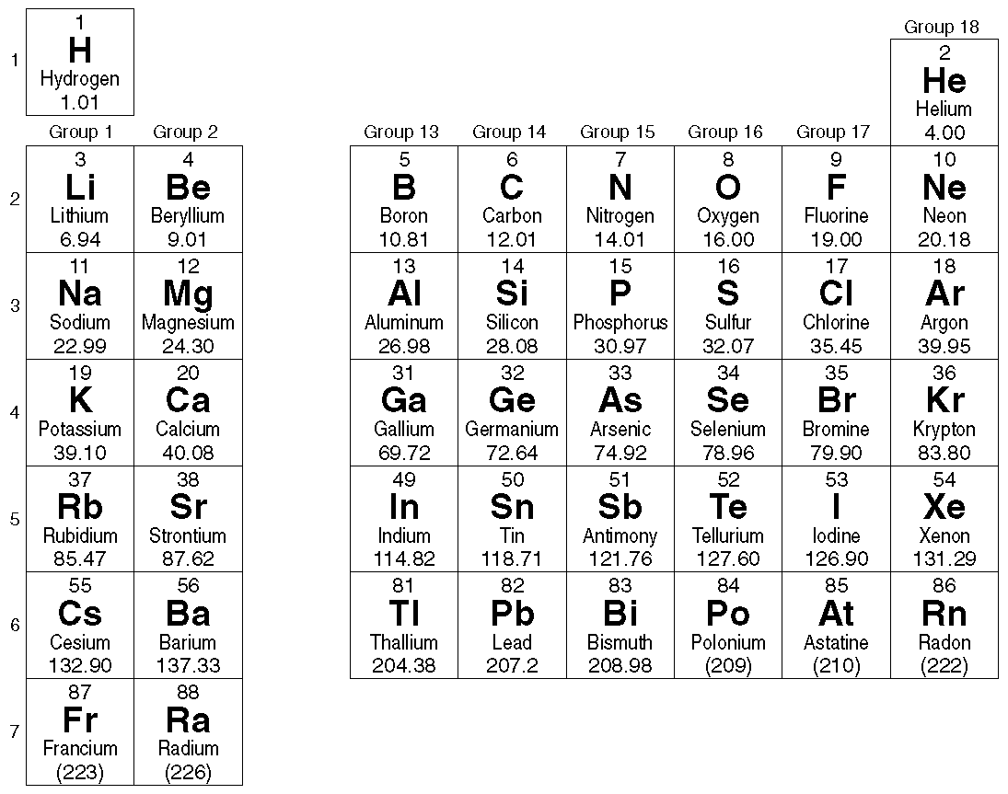

28. Which element has the following electron configuration: [Ar] 4*s*2 3*d*10 4*p*5?

29. Write the noble-gas electron configuration for silicon.

30. Draw the orbital diagram for phosphorus.

31. Draw the orbital diagram for argon.

32. Write the noble-gas electron configuration represented in the orbital diagram below.

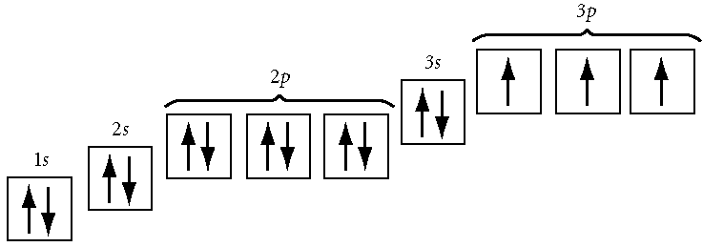

____ 33. Argon, krypton, and xenon are

|  |  |  |  |
| --- | --- | --- | --- |
| a. | alkaline earth metals. | c. | actinides. |
| b. | noble gases. | d. | lanthanides. |

Answers

1. B
2. A
3. D
4. B
5. C
6. B
7. D
8. A
9. C
10. D
11. A
12. D
13. B
14. A
15. C
16. D
17. C
18. C
19. A
20. B
21. B
22. D
23. B
24. C
25. D
26. C
27. D
28. Br
29. [Ne] 3*s*2 3*p*2
30. X
31. X
32. [Ne] 3*s*2 3*p*3
33. B
34. D
35. C
36. A
37. D
38. A
39. D
40. A
41. A
42. A