**Name: Period: Seat#:**

**S – 20B**

**Directions**: Any questions that were not completed in class as part of the Bing-Bing-Toe Game need to be finished as homework. Here are all the questions that were part of the review game if you missed any during the game, didn’t finish the game in class, or you were absent. Remember to show work for ANY math problems, include ALL units, and non-math questions should have good/detailed answers but do not need to be in sentence form unless asked for specifically.

1. How many atoms are in one molecule of Al(OH)3 ?
2. What particle did Thompson discover and which experiment proved it?
3. What Three parts of Dalton’s theory remain true today?
4. Do any of these atoms represent isotopes? If so, which ones and why?

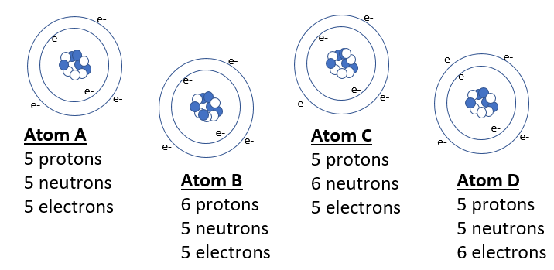

1. What Two parts of Dalton’s theory have been proven false?
2. Name the phases of matter.
3. Name all phase changes and what phases the change is between.
4. Draw a diagram for Rutherford’s Experiment. Explain what it proved about atomic structure
5. Name an element with similar properties to Iodine.
6. How do you calculate mass number?
7. How many valence Electrons do Halogen elements have?
8. Define chemical change and physical change. Give an example of each.
9. Name the three subatomic particles and give their relative masses.
10. Convert 15mi/day into in/sec
11. Classify Each Substance Below as: Pure Substance (element or compound) Mixture (homogeneous or heterogeneous).  
    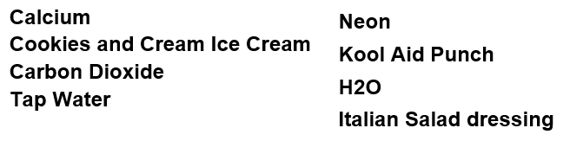
12. How many valence electrons do the alkali metals have and what is the charge of their ions?
13. What radioactive emission changes a neutron into a proton?
14. Scientists discover some new elements. Using the data below, which is most likely to be radioactive?   
    Yy, Xx, Zz, Xy
15. What radioactive emission changes a neutron into a proton?
16. How many protons and neutrons are in the nuclei   
    of Tl-204 atoms?
17. Uranium-235 undergoes alpha emission. What is the balanced eq.?
18. Neutron initiated fission of U-235 results in the release of 4 beta particles, the formation of Sr-90 and the release of another nucleus. What is the other nucleus?
19. Calculate the average atomic mass of Magnesium from these data. Magnesium occurs in nature in   
    three isotopic forms: Mg-24 (78.70% abundance) ,   
    Mg-26 (11.17% abundance) , Mg-25 (10.13% abundance)
20. What is nuclear fission?
21. A substance has a density of 1.39g/ml. You have 10g of the substance. What volume (in L) do you have?
22. How many decigrams are in 437 kg? Write in scientific notation!
23. How many sig. figs are in the following values?   
    612 kg 0.00067 ml 309.4 g
24. Perform the calculation using accurate sig figs   
    1.31 cm x 2.3 cm =
25. Perform the calculation using accurate sig figs   
    8.264 g - 7.8 g =
26. What holds the nucleus together so the repulsion between protons doesn’t make the atom fly apart?