**Spring Final Exam Practice Test #1**

**PART 1**

|  |  |  |
| --- | --- | --- |
| 1. | How many protons neutrons electrons are in Carbon-12 | |
| A) | 12, 12, 12 |
| B) | 6, 12, 6 |
| C) | 12, 12, 6 |
| D) | 12, 6, 12 |
| E) | 6, 6, 6 |

|  |  |  |
| --- | --- | --- |
| 2. | How many protons and electrons are in an aluminum ion | |
| A) | 13p, 16e |
| B) | 13p, 13e |
| C) | 13p, 10e |
| D) | 10p, 13e |
| E) | 10p, 10e |

|  |  |  |
| --- | --- | --- |
| 3. | Which of the subatomic particles below has the greatest mass | |
| A) | Electrons |
| B) | Protons |
| C) | Neutrons |
| D) | Helium atom |
| E) | None of these |

|  |  |  |
| --- | --- | --- |
| 4. | Which of the below ions has a charge of -2 | |
| A) | F |
| B) | Mg |
| C) | Ca |
| D) | S |
| E) | Ne |

|  |  |  |
| --- | --- | --- |
| 5. | Which subatomic particles are in the atoms nucleus | |
| A) | Electron, Proton |
| B) | Proton, Neutron |
| C) | Electron, Neutron |
| D) | Proton, Electron, Neutron |
| E) | The nucleus in empty space |

|  |  |  |
| --- | --- | --- |
| 6. | Which of the below orbitals is not possible | |
| A) | 2s |
| B) | 6f |
| C) | 5d |
| D) | 6p |
| E) | 3f |

|  |  |  |
| --- | --- | --- |
| 7. | What is the electron configuration for tin | |
| A) | 1s22s22p63s23p2 |
| B) | 1s22s22p63s23p64s23d104p65s24d105p2 |
| C) | 1s22s22p63s23p64s23d104p2 |
| D) | 1s22s22p63s23p64s23d104p65s24d105p66s25d2 |
| E) | 1s22s22p63s23p64s23d104p65s24d6 |

|  |  |  |
| --- | --- | --- |
| 8. | What is the noble gas configuration of Chlorine | |
| A) | [Mg] 3p5 |
| B) | [Ar] 3s23p5 |
| C) | [Ne] 3s23p5 |
| D) | [S] 3s23p5 |
| E) | [Na] 3s23p5 |

|  |  |  |
| --- | --- | --- |
| 9. | By what process does thorium-230 decay to radium-226 | |
| A) | Gamma emission |
| B) | Alpha emission |
| C) | Beta emieeion |
| D) | Positron emission |
| E) | None of these |

|  |  |  |
| --- | --- | --- |
| 10. | 131I has a half-life of 8.04 days. Assuming you start with a 1.53 mg sample of 131I, how many mg will remain after 13.0 days? | |
| A) | 0.835 |
| B) | 0.268 |
| C) | 0.422 |
| D) | 0.440 |
| E) | 0.499 |

|  |  |  |
| --- | --- | --- |
| 11. | The missing product from this reaction is ________. | |
| A) |  |
| B) |  |
| C) |  |
| D) |  |
| E) |  |

|  |  |  |
| --- | --- | --- |
| 12. | The beta decay of cesium-137 has a half-life of 30.0 years. How many years must pass to reduce a 25 mg sample of cesium 137 to 8.7 mg? | |
| A) | 46 |
| B) | 32 |
| C) | 3.2 |
| D) | 50 |
| E) | 52 |

|  |  |  |
| --- | --- | --- |
| 13. | Which one of the following forms of radiation can penetrate the deepest into the body tissue | |
| A) | Alpha |
| B) | Beta |
| C) | Gamma |
| D) | Proton |
| E) | Helium nucleus |

|  |  |  |
| --- | --- | --- |
| 14. | What type of matter is Hg | |
| A) | Metal |
| B) | Nonmetal |
| C) | Metalloid |
| D) | Solid (at 25oC) |
| E) | Gas (at 25oC) |

|  |  |  |
| --- | --- | --- |
| 15. | Put these elements in order of greatest to smallest electronegativity (Ga, Ca, Cl) | |
| A) | Ga<Ca<O |
| B) | Ca<O<Ga |
| C) | O<Ga<Ca |
| D) | Ca<Ga<O |
| E) | O<Ca<Ga |

|  |  |  |
| --- | --- | --- |
| 16. | Which of the following compounds are ionic bonds | |
| A) | H2O |
| B) | CH4 |
| C) | AlF3 |
| D) | NO2 |
| E) | Cl2 |

|  |  |  |
| --- | --- | --- |
| 17. | Which of the following compounds in covalent | |
| A) | NaCl |
| B) | SO2 |
| C) | Ca(OH)2 |
| D) | Fe |
| E) | KBr |

|  |  |  |
| --- | --- | --- |
| 18. | Which of the below elements is nonpolar | |
| A) | H2O |
| B) | NH3 |
| C) | O2 |
| D) | SBr4 |
| E) | NaCl |

|  |  |  |
| --- | --- | --- |
| 19. | How are ionic bonds different then metallic and covalent bonds | |
| A) | They are made of two or more elements |
| B) | They are made of two or more different elements |
| C) | They contain nonmetals |
| D) | They contain metals |
| E) | None of these |

|  |  |  |
| --- | --- | --- |
| 20. | A particular radioisotope has a half-life of 15 years. What percentage of the isotope will remain after 45 years | |
| A) | 100% |
| B) | 50% |
| C) | 25% |
| D) | 12.5% |
| E) | 6.25% |

**PART 2**

|  |  |  |
| --- | --- | --- |
| 1. | Name the compound below S2O | |
| A) | sulfur dioxide |
| B) | disulfur oxide |
| C) | disulfur dioxide |
| D) | disulfur trioxide |
| E) | monosulfur monoxide |

|  |  |  |
| --- | --- | --- |
| 2. | What is the formula for ammonium sulfate | |
| A) | (NH3)3SO4 |
| B) | NH4S |
| C) | (NH4)2SO4 |
| D) | NSO4 |
| E) | NH4SO4 |

|  |  |  |
| --- | --- | --- |
| 3. | How many oxygens are in the compound below Al2(SO4)3 | |
| A) | 8 |
| B) | 7 |
| C) | 4 |
| D) | 3 |
| E) | 12 |

|  |  |  |
| --- | --- | --- |
| 4. | A valid Lewis structure of __________ cannot be drawn without violating the octet rule. | |
| A) | NF3 |
| B) | BeH2 |
| C) | SO2 |
| D) | CF4 |
| E) | SO32- |

|  |  |  |
| --- | --- | --- |
| 5. | The molecular geometry of CH2Cl2 molecule is | |
| A) | Trigonal planar |
| B) | Tetrahedral |
| C) | Trigonal pyramidal |
| D) | Octahedral |
| E) | Bent |

|  |  |  |
| --- | --- | --- |
| 6. | The molecular geometry of the SF2 molecule is | |
| A) | Linear |
| B) | Tetrahedral |
| C) | Trigonal planar |
| D) | Trigonal pyramidal |
| E) | Bent |

|  |  |  |
| --- | --- | --- |
| 7. | Which lewis dot structure below is correct for O2 | |
| A) | :O=O: |
| B) | :O—O: |
| C) | :O=O |
| D) | :O=O: |
| E) | O--O |

|  |  |  |
| --- | --- | --- |
| 8. | When the following equation is balanced, the coefficients are  NH3 (g) + O2 (g) 🡪 NO2 (g) + H2O (g) | |
| A) | 1, 1, 1, 1 |
| B) | 4, 7, 4, 6 |
| C) | 2, 3, 2, 3 |
| D) | 1, 3, 1, 2 |
| E) | 4, 3, 4, 3 |

|  |  |  |  |  |
| --- | --- | --- | --- | --- |
| 9. | When the following reaction is balanced the sum of the coefficients is FeCl3 (aq) + H2S (g) 🡪 Fe2S3 (s) + HCl (aq) | |  |  |
| A) | 12 |  |  |
| B) | 11 |  |  |
| C) | 4 |  |  |
| D) | 7 |  |  |
| E) | 9 |  |  |

|  |  |  |
| --- | --- | --- |
| 10. | What type of reaction is below 2C2H6 + 7O2 🡪 4CO2 + 6H2O | |
| A) | Single displacement |
| B) | Double displacement |
| C) | Synthesis |
| D) | Combustion |
| E) | Decomposition |

|  |  |  |
| --- | --- | --- |
| 11. | Calculate the molar mass of AlPO4 | |
| A) | 73g/mole |
| B) | 100g/mole |
| C) | 122g/mole |
| D) | 95g/mole |
| E) | 138g/mole |

|  |  |  |
| --- | --- | --- |
| 12. | How many moles are in 100g of water? | |
| A) | 2.50 moles |
| B) | 3 moles |
| C) | 10 moles |
| D) | 5.55 moles |
| E) | 7.50 moles |

|  |  |  |
| --- | --- | --- |
| 13. | How many atoms are in 25g of Calcium | |
| A) | 3.75E23 atoms |
| B) | 6.24E-2 atoms |
| C) | 5.34E12 atoms |
| D) | 4.08E23 atoms |
| E) | 6.02E23 atoms |

|  |  |  |
| --- | --- | --- |
| 14. | How many grams are in 12 atoms of carbon | |
| A) | 12.01g |
| B) | 6.00g |
| C) | 2.39g |
| D) | 1.25E-23g |
| E) | 2.39E-22g |

|  |  |  |
| --- | --- | --- |
| 15. | The combustion of propane  produces and: C3H8 (g) + 5O2 (g) 🡪 3CO2 (g) + 4H2O (g)  The reaction of 2.5 mol of  will produce __________ mol of. | |
| A) | 4.0 |
| B) | 3.0 |
| C) | 2.5 |
| D) | 2.0 |
| E) | 1.0 |

|  |  |  |
| --- | --- | --- |
| 16. | Calcium carbide (CaC2) reacts with water to produce acetylene: (C2H2) CaC2 (s) + 2H2O (g) 🡪 Ca(OH)2 (s) + C2H2 (g)  Production of 13 g of C2H2 requires consumption of __________ g of H2O. | |
| A) | 4.5 |
| B) | 9.0 |
| C) | 18 |
| D) | 4.8E2 |
| E) | 4.8E-2 |

|  |  |  |
| --- | --- | --- |
| 17. | A balloon has a volume of 500ml at 25oC. If the balloon is heated on a hot day to 35oC what will its new volume be? | |
| A) | 251ml |
| B) | 755ml |
| C) | 517ml |
| D) | 865ml |
| E) | 453ml |

|  |  |  |
| --- | --- | --- |
| 18. | A sample oargon gas at standard pressure occupies 1000. mL. At constant temperature, what volume does the gas occupy if the pressure increases to 800. mm Hg? | |
| A) | 500ml |
| B) | 950ml |
| C) | 760ml |
| D) | 640ml |
| E) | 1053ml |

|  |  |  |
| --- | --- | --- |
| 19. | If a gas with an odor is released in a room, it quickly can be detected across the room because it | |
| A) | Diffuses |
| B) | Is dense |
| C) | Is compressed |
| D) | Condenses |
| E) | Effuses |

|  |  |  |
| --- | --- | --- |
| 20. | The gas pressure in a container decreases when | |
| A) | The number of gas molecules is increased |
| B) | The number of gas molecules is decreased |
| C) | The temperature is increased |
| D) | The number of molecules is increased and the temperature is increased |
| E) | The volume is decreased |

|  |  |  |
| --- | --- | --- |
| 21. | A pressure of 1.00 atm is the same as the pressure of ________mmHg | |
| A) | 193 |
| B) | 101 |
| C) | 29.9 |
| D) | 760 |
| E) | 33.0 |

|  |  |  |
| --- | --- | --- |
| 22. | The amount of gas that occupies 60.82L at 31oC and 367 mmHg is | |
| A) | 1.18 moles |
| B) | 0.850 moles |
| C) | 1.18 grams |
| D) | 11.6 moles |
| E) | 0.120 grams |

|  |  |  |
| --- | --- | --- |
| 23. | At a temperature of __________ °C, 0.444 mol of CO gas occupies 11.8 L at 889 torr. | |
| A) | 379oC |
| B) | 73 oC |
| C) | 14 oC |
| D) | 32 oC |
| E) | 106 oC |

|  |  |  |
| --- | --- | --- |
| 24. | A sample of gas (1.3 mol) occupies __________ L at 22 °C and 2.5 atm. | |
| A) | 0.079L |
| B) | 0.94L |
| C) | 13L |
| D) | 31L |
| E) | 3.2E-2L |

|  |  |  |
| --- | --- | --- |
| 25. | A sample of gas (1.9 mol) is in a flask at 21 °C and 697 mm Hg. The flask is opened and more gas is added to the flask. The new pressure is 795 mm Hg and the temperature is now 26 °C. There are now __________ mol of gas in the flask. | |
| A) | 1.6 mole |
| B) | 2.1 mole |
| C) | 2.9 mole |
| D) | 3.5 mole |
| E) | 0.28 mole |

**PART 3**

|  |  |  |
| --- | --- | --- |
| 1. | What is absolute zero | |
| A) | The point at which matter loses all its mass |
| B) | The point at with matter has no pressure |
| C) | The point at with matter has no temperature |
| D) | The point at which matter has no kinetic energy |
| E) | Both D and C |

|  |  |  |
| --- | --- | --- |
| 2. | What is the absolute temperature at 35oC | |
| A) | 268K |
| B) | 308K |
| C) | 208K |
| D) | 388K |
| E) | 225K |

|  |  |  |
| --- | --- | --- |
| 3. | Which is the correct units for specific heat | |
| A) | J |
| B) | J/g |
| C) | J/oC.K |
| D) | J/g.oC |
| E) | J/K |

|  |  |  |
| --- | --- | --- |
| 4. | What is the unit for energy as heat flow | |
| A) | K |
| B) | M |
| C) | J |
| D) | C |
| E) | T |

|  |  |  |
| --- | --- | --- |
| 5. | How much energy is produced if 23g of aluminum is heated from 25oC to 85oC? specific heat of Al = 0.900j/g.K | |
| A) | 1,242J |
| B) | 1,450K |
| C) | 1,326J |
| D) | 987J |
| E) | 8325J |

|  |  |  |
| --- | --- | --- |
| 6. | How many grams of glass are heated with 1,845 joules of energy from 25oC to 78oC? The specific heat of glass = 0.840J/g.K | |
| A) | 34.8gg |
| B) | 41.4g |
| C) | 45.3g |
| D) | 27.3g |
| E) | 54.3g |

|  |  |  |
| --- | --- | --- |
| 7. | 25g of water A at 25oC is mixed with 25g of water B producing a final temperature of 45oC. What is the initial temperature of water B? | |
| A) | 10oC |
| B) | 32oC |
| C) | 65oC |
| D) | 74oC |
| E) | 85oC |

|  |  |  |
| --- | --- | --- |
| 8. | How much energy is absorbed to heat 53g of ice at -15oC to steam at 120oC? | |
| A) | 123,546J |
| B) | 43,695J |
| C) | 163,475J |
| D) | 213,453J |
| E) | 143,845J |

|  |  |  |
| --- | --- | --- |
| 9. | 35g of water at 25oC is cooled to -15oC how much energy is released? | |
| A) | 16,448J |
| B) | 23,943J |
| C) | 10,943J |
| D) | 4.18J |
| E) | 45,324J |

|  |  |  |
| --- | --- | --- |
| 10. | Which substance in the reaction below either appears or disappears the fastest?  4NH3 + 7O2 🡪 4NO2 + 6H2O | |
| A) | The rate of appearance/disappearance are the same for all these |
| B) | NH3 |
| C) | NO2 |
| D) | H2O |
| E) | O2 |

|  |  |  |
| --- | --- | --- |
| 11. | A burning splint will burn more vigorously in pure oxygen than in air because. | |
| A) | Oxygen is a reactant in combustion and concentration of oxygen is higher in pure oxygen than is in air |
| B) | Oxygen is a catalyst for combustion |
| C) | Oxygen is a product of combustion |
| D) | Air has a slowing affect on the combustion reaction |
| E) | Oxygen as a product of the reaction helps to speed it up |

|  |  |  |
| --- | --- | --- |
| 12. | Which one of the following is not a valid expression for the rate of the reation below?  4NH3 + 7O2 🡪 4NO2 + 6H2O | |
| A) |  |
| B) |  |
| C) |  |
| D) |  |
| E) | All of the above are valid |

|  |  |  |
| --- | --- | --- |
| 13. | A strong electrolyte is one that __________ completely in solution | |
| A) | Reacts |
| B) | Disscociates |
| C) | Disappears |
| D) | Associates |
| E) | produces |

|  |  |  |
| --- | --- | --- |
| 14. | The phrase “like dissolves like” refers to the fact that.. | |
| A) | Gases can only dissolve other gases |
| B) | Solvents can olny dissolve solutes of similar molar mass |
| C) | Polar solvents dissolve polar solutes and nonpolar solvents dissolve nonpolar solutes |
| D) | Condensed phases can only dissolve other condensed phases |
| E) | Polar solvents dissolve nonpolar solutes and vice versa |

|  |  |  |
| --- | --- | --- |
| 15. | In a soda drink the CO2 is the __________ and the water is the ______________. | |
| A) | Liquid, gas |
| B) | Solvent, solute |
| C) | Solvent, solvent |
| D) | Solute, solute |
| E) | Solute, solvent |

|  |  |  |
| --- | --- | --- |
| 16. | Calculate the molar concentraio of HCl in a solution prepared by dissolving 5.5g of HCl in 200g of C2H6O .the density of the solution is 0.79g/ml | |
| A) | 0.58 |
| B) | 0.93 |
| C) | 6.0E-6 |
| D) | 1.72 |
| E) | 21 |

|  |  |  |
| --- | --- | --- |
| 17. | How many liters of a 5 molar KOH solution contains 2.5 moles | |
| A) | 1L |
| B) | 0.5L |
| C) | 2L |
| D) | 0.2L |
| E) | 5L |

|  |  |  |
| --- | --- | --- |
| 18. | In a acid base neutralization these produces are produced. | |
| A) | Acid and base |
| B) | Base and water |
| C) | Salt and water |
| D) | Acid and salt |
| E) | Water and acid |

|  |  |  |
| --- | --- | --- |
| 19. | What is the concentration of H+ in a solution with a pH = 3.4 | |
| A) | 1.0E-3 |
| B) | 2.1E-4 |
| C) | 5.3E-4 |
| D) | 4.0E-4 |
| E) | 6.5E-4 |

|  |  |  |
| --- | --- | --- |
| 20. | What is the pH of a solution with 2.5E-5 molar of HCl | |
| A) | 3.25 |
| B) | 5.00 |
| C) | 2.54 |
| D) | 5.42 |
| E) | 4.60 |

**PART 4**

|  |  |  |
| --- | --- | --- |
| 1. | The maximum number of electrons allowed in **each** of the d orbitals in | |
| A) | 2 |
| B) | 4 |
| C) | 10 |
| D) | 14 |
| E) | 18 |

|  |  |  |
| --- | --- | --- |
| 2. | Which of the following electron configurations represents Tin(IV) | |
| A) | 1s22s22p63s23p64s23d104p65s24d105p2 |
| B) | 1s22s22p63s23p64s23d104p64d10 |
| C) | 1s22s22p63s23p64s23d104p65s2 |
| D) | 1s22s22p63s23p64s23d104p65s24d85p2 |
| E) | 1s22s22p63s23p64s23d104p65s1 |

|  |  |  |
| --- | --- | --- |
| 3. | Ionization energy, the ability to remove an electron in the gaseous state, changes as you move across (L-R) the periodic table and down a group. Which of the following best describes that trend? (respectively periods/groups | |
| A) | Decrease /decrease |
| B) | Decrease/ increase |
| C) | Increase/ decrease |
| D) | Increase / increase |
| E) | No change |

|  |  |  |
| --- | --- | --- |
| 4. | What is the chemical formula for mercury(I) chloride | |
| A) | Hg2Cl |
| B) | HgCl2 |
| C) | HgCl |
| D) | Hg2Cl2 |
| E) | Hg2Cl4 |

|  |  |  |
| --- | --- | --- |
| 5. | Two atoms of element A unite to form a molecule with formula A2, the bond between atoms in the molecules is | |
| A) | metallic |
| B) | Electrovalent |
| C) | Polar covalent |
| D) | Ionic |
| E) | Non-polar covalent |

|  |  |  |
| --- | --- | --- |
| 6. | All of the following are metals except | |
| A) | Hg |
| B) | Al |
| C) | Na |
| D) | N |
| E) | Ag |

|  |  |  |
| --- | --- | --- |
| 7. | How many hydrogen atoms are indicated by the formula (NH4)2C8H4O2 | |
| A) | 12 |
| B) | 8 |
| C) | 20 |
| D) | 24 |
| E) | 16 |

|  |  |  |
| --- | --- | --- |
| 8. | The atomic particle having a mass of 4 amu and a charge of +2 is | |
| A) | An electron |
| B) | An alpha particle |
| C) | A proton |
| D) | A neutron |
| E) | A beta particle |

|  |  |  |
| --- | --- | --- |
| 9. | If Pb undergoes a beta decay and the product of this decay undergoes another beta decay, which nuclide is produced? | |
| A) | Bi |
| B) | Pb |
| C) | Po |
| D) | Bi |
| E) | Pb |

|  |  |  |
| --- | --- | --- |
| 10. | A particular radioactive element has a half-life of 4.00 weeks. What percent of the original sample is left after 19.5 days? | |
| A) | 75% |
| B) | 25% |
| C) | 52% |
| D) | 12.5% |
| E) | 62% |

|  |  |  |
| --- | --- | --- |
| 11. | Which of the following is the highest energy orbital for a silicon atom? | |
| A) | 3p |
| B) | 1s |
| C) | 3d |
| D) | 2s |
| E) | 2p |

|  |  |  |
| --- | --- | --- |
| 12. | What would happen to the average kinetic energy of the molecules of a gas sample if the temperature of the sample increased from 20°C to 40°C? | |
| A) | It would double |
| B) | In would increase |
| C) | It would decrease |
| D) | It would become half its value |
| E) | Two of these |

|  |  |  |
| --- | --- | --- |
| 13. | Gaseous chlorine is held in two separate containers at identical temperature and pressure. The volume of container 1 is 1.30 L and it contains 6.70 mol of the gas. The volume of container 2 is 2.52 L. How many moles of the gas are in container 2? | |
| A) | 0.489 mol |
| B) | 21.0 mol |
| C) | 13.0 mol |
| D) | 3.46 mol |
| E) | 15.0 mol |

|  |  |  |
| --- | --- | --- |
| 14. | It is found that 250. mL of a gas at STP has a mass of 1.84 g. What is the molar mass? | |
| A) | 7.36 g/mol |
| B) | 11.2 g/mol |
| C) | 22.4 g/mol |
| D) | 165 g/mol |
| E) | 48.7 g/mol |

|  |  |  |
| --- | --- | --- |
| 15. | As water freezes the energy in the reaction is | |
| A) | Absorbed |
| B) | Neither |
| C) | Both a and e |
| D) | Does not change |
| E) | Released |

|  |  |  |
| --- | --- | --- |
| 16. | Which of the following processes is exothermic? | |
| A) | Rolling a ball up hill |
| B) | Boiling water in a beaker to make steam |
| C) | Allowing meat to thaw after taking it out of the freezer |
| D) | Reacting hydrogen and oxygen gases to make water |
| E) | A popsicle meting on a warm summer day |

|  |  |  |
| --- | --- | --- |
| 17. | A solution has a pH of 7.34. The solution H+ concentration is | |
| A) | 1.00E-7 |
| B) | 4.57E-8 |
| C) | 2.34E-9 |
| D) | 3.12E-7 |
| E) | 8.32E-8 |

|  |  |  |
| --- | --- | --- |
| 18. | What is the concentration of [OH-} if you have 3.45E-6 M of [H+] | |
| A) | 1.00E-8 |
| B) | 3.45E-8 |
| C) | 2.90E-9 |
| D) | 4.29E-7 |
| E) | 7.54E-7 |

|  |  |  |
| --- | --- | --- |
| 19. | Calculate the [H+] in a solution that has a pOH of 11.39. | |
| A) | 2.45E-3 |
| B) | 3.67E-10 |
| C) | 4.07E-12 |
| D) | 5.36E-12 |
| E) | 6.32E-3 |

|  |  |  |
| --- | --- | --- |
| 20. | How long does it take californium-254 to decay from 98g to 25g if it has a half-life of 60.5 days | |
| A) | 119 days |
| B) | 154 days |
| C) | 2 weeks |
| D) | 119 seconds |
| E) | 60.5 days |

|  |  |  |
| --- | --- | --- |
| 21. | What is the final temperature if 25g of water at 25oC are poured it to 45g of water at 96oC? | |
| A) | 34.5 oC |
| B) | 70.7 oC |
| C) | 63 oC |
| D) | 58.3 oC |
| E) | 74.3 oC |

A general reaction written as A + 2B  C + 2D is studied and yields the following data:

|  |  |  |  |  |
| --- | --- | --- | --- | --- |
|  | | [A]0 | [B]0 | Initial [C]/*t* |
|  | | 0.150 M | 0.150 M | 8.00  10–3 mol/L·s |
|  | | 0.150 M | 0.300 M | 1.60  10–2 mol/L·s |
|  |  | 0.300 M | 0.150 M | 3.20  10–2 mol/L·s |

|  |  |  |
| --- | --- | --- |
| 22. | What is the value of the rate constant | |
| A) | 0.053 |
| B) | 1.19 |
| C) | 2.37 |
| D) | 5.63 |
| E) | none of these (a-d) |

|  |  |  |
| --- | --- | --- |
| 23. | The [OH-] in a 0.62 M pyridine (C5H5N; *K*b = 1.7  10-9) solution is | |
| A) | 1.1E-9M |
| B) | 3.2E-5M |
| C) | 0.62M |
| D) | 5.2E-5M |
| E) | 4.2E-4M |

|  |  |  |
| --- | --- | --- |
| 24. | The [H3O+] of a 0.77 M solution of NH4Cl in H2O at 25°C is (*K*b for NH3 = 1.8  10-5): | |
| A) | 4.3E-10 M |
| B) | 3.7E-3 M |
| C) | 2.1E-5 M |
| D) | 0.77 M |
| E) | 3.5E-4 M |

|  |  |  |
| --- | --- | --- |
| 25. | Calculate the density of chlorine gas at STP. | |
| A) | 2.24g/l |
| B) | 1.58g/l |
| C) | 3.16g/l |
| D) | 4.35g/l |
| E) | 5.98g/l |

|  |  |  |
| --- | --- | --- |
| 26. | Exactly 223.4 J will raise the temperature of 10.0 g of a metal from 25.0°C to 60.0°C. What is the specific heat capacity of the metal? | |
| A) | 0.843 J/g.K |
| B) | 13.8 J/g.K |
| C) | 53.4 J/g.K |
| D) | 1.57 J/g.K |
| E) | 0.638 J/g.K |

**PART 5**

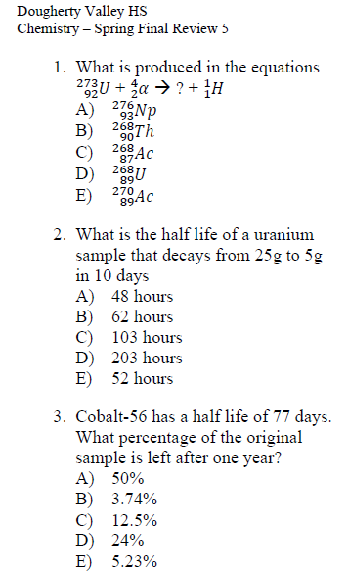

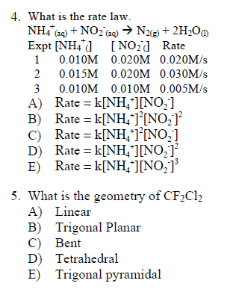

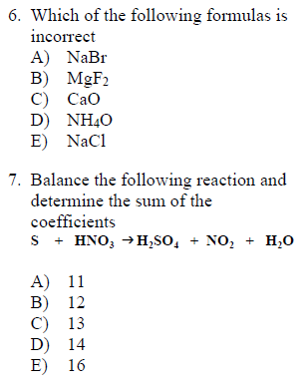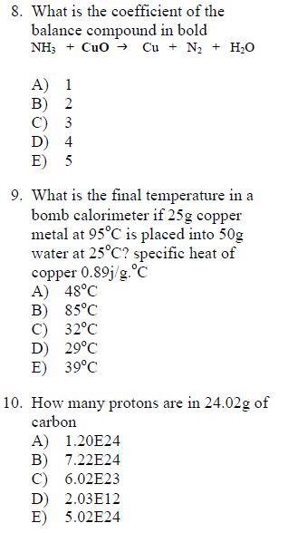

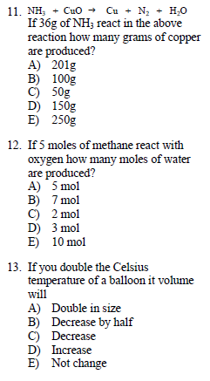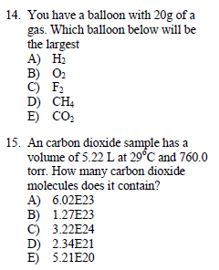

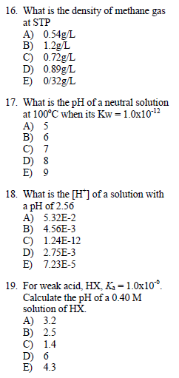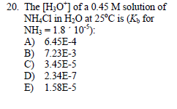

**PART 6**