Introduction
Analysis of Ag in an Alloy

Alloys are solid solutions of two or more metals. Alloys are made to modify the properties of pure metals. For example, sterling silver, an alloy of silver and copper, retains the bright luster of silver but is much stronger and more rigid than pure silver.

Concepts
- Oxidation-reduction reaction • Gravimetric analysis • Precipitation reaction

Background
Silver and copper are very nonreactive metals. Neither will dissolve in hydrochloric acid or sulfuric acid. The "oxidizing" acid nitric acid, HN0₃, is required. In acidic solutions the nitrate ion is an excellent oxidizer, and it will oxidize Ag(s) to Ag⁺(aq) and Cu(s) to Cu²⁺(aq). The reduction product is the gas NO. As the colorless nitrogen monoxide gas forms, it immediately reacts with the oxygen in the air to produce the orange-brown gas N0₂. The half-reactions for the oxidation of silver and copper by nitric acid are as follows:
Ag(s) → Ag⁺(aq) + e⁻ Cu(s) → Cu²⁺(aq) + 2e⁻
4H⁺(aq) + NO₃⁻ (aq) + 3e⁻ → NO(g) + 2H₂O(l)
Once the silver and copper ions are in solution, they can be separated from each other by precipitating the silver ions as silver chloride. Silver chloride (AgCl) is very insoluble in water, while copper(II) chloride (CuCl₂) is soluble. The addition of chloride ions to the solution will precipitate essentially all of the silver and none of the copper. The silver chloride precipitate is then filtered from the solution.

Experiment Overview
In this experiment an alloy of silver will be analyzed to determine its silver content. The silver-copper alloy will be dissolved in nitric acid, the silver will be precipitated as silver chloride, and the silver chloride will be filtered, washed, dried and its mass determined. From the mass of the silver chloride formed and the mass of the original sample, the percent of silver in the alloy is calculated. Because the results are based on the mass of a product, this procedure is classified as a gravimetric analysis.

Pre-lab Questions (Part of your pre-lab assignment)
Before beginning work on this experiment, read the directions and answer the following questions:
- What is the difference between qualitative and quantitative analytical methods?
- Why is it possible to analyze the silver content of a silver-copper alloy by precipitating with chloride ion?
- Is there any other ion, besides chloride, that could be used in this procedure? If so, why would this ion work?
- A silver-copper alloy had a mass of 0.1264 g. When the alloy was dissolved in nitric acid and the silver precipitated as silver chloride, the precipitate had a mass of 0.1375 g. Calculate the percent of silver in the alloy. Show your calculations.
- If the silver chloride is not dry when its mass is determined, will the calculated percent of silver in the alloy be too high or too low? Explain.

Materials
Chemicals
Silver-copper alloy, 0.2 to 0.5-g piece | Nitric acid solution, HN0₃. 6 M, 12 ml.
Equipment
Aspirator | Balance, 0.001-g or 0.0001-g precision
Beakers, 100-mL, 3 | Bunsen burner (or hot plate)
Crucible tongs | Drying oven
Filter flask | Fume hood
Gooch crucible and fiberglass pad, or | sintered glass filter crucible

Sodium chloride, NaCl, 0.8 g | Graduated cylinder, 50-mL
Graduated cylinder, 250-mL | Heat-resistant pad
Parafilm® or plastic wrap | Ring stand, ring, wire gauze
Rubber or plastic policeman | Stirring rod
Wash bottle with distilled or deionized water | Watch glass
Weighing dishes, 2

Safety Precautions
Nitric acid solution is severely corrosive, a strong oxidant, and toxic by ingestion and inhalation. Solutions containing silver cause dark stains on skin and clothing that do not appear for several hours. As the silvercopper alloy dissolves, the toxic gases nitrogen monoxide, NO, and nitrogen dioxide, N0₂ are evolved. Carry out the reaction in a fume hood or under a funnel attached to an aspirator. Wear chemical splash goggles, chemical-resistant gloves, and a chemical-resistant apron. Wash hands thoroughly with soap and water before leaving the laboratory.

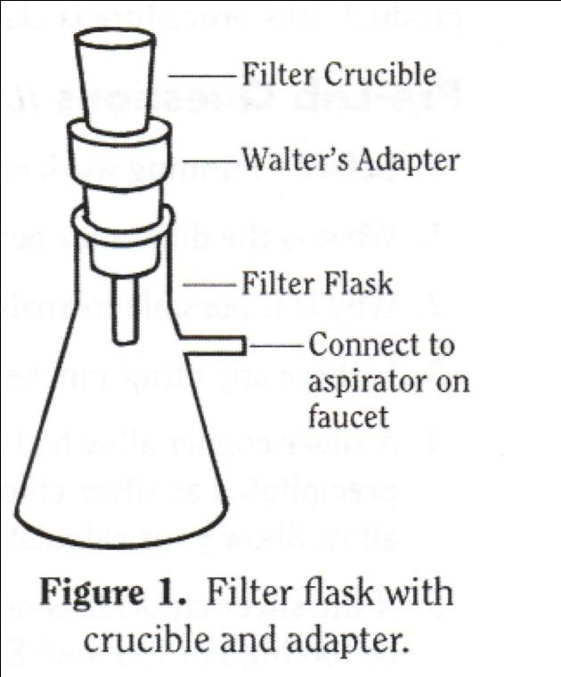
Procedure
- To filter the solution, either a Gooch crucible or a sintered glass filter crucible will be used with a filter flask. Refer to Figure 1 to see how the crucible, Walter's adapter, and filter flask are assembled.

- If using a Gooch crucible, clean it, place a fiberglass filter pad in the crucible and pull distilled or deionized water through the assembly to be sure the filter pad is seated tightly on the bottom of the crucible.

- If using a sintered glass filter crucible, clean it and rinse it with distilled or deionized water using suction.

- Place the Gooch or sintered glass filter crucible in a clean 100-mL beaker and dry it in an oven at 110 °C. After 10 minutes, remove the beaker with crucible tongs and place it on a heat-resistant pad.

- When the crucible has cooled, determine its mass using an analytical balance. Record this mass in the Data Table. Be careful not to handle the crucible with your fingers so that no fingerprints will be present.

- Obtain a sample of silver alloy that is between 0.1 and 0.5 g. Determine its mass precisely on a sensitive balance. Record this value in the Data Table.

- Put the alloy in a clean 100-mL beaker, and carefully pour 10 mL of 6 M nitric acid over it.

- Cover the beaker with a watch glass so none of the solution spatters out. It may be necessary to gently heat the solution so that the alloy dissolves.

- Allow the alloy to totally dissolve.

- Calculate the amount of sodium chloride that would be necessary to precipitate the silver in your sample, assuming that the sample is 100% silver. Enter this value in the Data Table.

- Weigh out two times this amount of sodium chloride.

- Dissolve the sodium chloride in 25 mL of distilled or deionized water in a 100-mL beaker.

- Remove the watch glass from the first beaker, and rinse any moisture on the bottom of the watch glass back into the beaker with your wash bottle.

- To precipitate the silver as silver chloride, slowly add the sodium chloride solution to the dissolved silver. Stir with a stirring rod, and use distilled or deionized water to rinse any solution clinging to the rod back into the beaker.

- Gently heat (without boiling) the solution for about 15 minutes. This will cause the precipitate particles to grow larger so they are easier to filter. Alternatively, cover the beaker with Parafilm® or plastic wrap and allow it to stand overnight. This will also allow the particles to grow larger.

- Attach the Gooch crucible or filter crucible to the Walter's adapter in the filter flask. Pour some distilled or deionized water through the filter with suction to be sure that the filter pad firmly seals the bottom of the Gooch crucible.

- In your wash bottle, add 2 mL of 6 M HNO₃ to 150 mL of distilled or deionized water. Label your wash bottle appropriately. Use this as a rinse. The addition of the acid to the rinse water helps to keep the precipitate from "peptizing," or forming extremely small particles that will run through the filter.

- Carefully pour the solution above the silver chloride down a stirring rod into the crucible.

- Wash the precipitate into the crucible with the diluted nitric acid solution in the wash bottle. Be sure to get every particle! A rubber policeman on a stirring rod can be used as a squeegee to clean the sides of the beaker.

- Rinse the precipitate several times with the wash solution. Rinse w/ 10-ml of Alcohol
- Sandwich your solid between the small and a large piece of filter paper to dry overnight

- Remove the beaker with crucible tongs and place it on a heat-resistant pad.

- When the crucible has cooled, find its mass on the analytical balance. Record this value in the Data Table.

- If you have time, dry the crucible an additional 30 minutes and again determine its mass to see if it reached a constant value.

Disposal and Cleanup
Your teacher will provide disposal and cleanup instructions.

Data Table (Quantitative)
Mass of silver alloy, g
Mass of NaCl needed to precipitate the silver, g
Mass of NaCl used, g
Mass of dry filter crucible, g
Mass of crucible and AgCl, g
Mass of AgCl, g
Calculated percent of silver in silver chloride, by weight
Calculated mass of silver in alloy, g

Discussion: Post-Lab Calculations

PART OF STEP 14: Calculate the following:
  - The amount of NaCl needed to precipitate all the silver in the sample. Assume the sample is 100% silver.
  - Calculate the percent silver in silver chloride. Record this value in the Data Table.
  - From the mass of filtered silver chloride and the mass of the silver alloy sample, calculate the mass of silver in the alloy. Record this value in the Data Table.
- Why is a twofold excess of chloride added to precipitate the silver?
- Why doesn't the sodium chloride need to be weighed on a sensitive balance?
- Why is it necessary to wash the precipitate?
- Will the nitric acid in the wash water interfere with the weight of the silver chloride? (Nitric acid is prepared by dissolving the gas N₂O₅ in water.)
- If the crucible containing the silver chloride is not cool when its mass is determined, will the calculated percent silver be too high or too low? Why?
- Why isn't hydrochloric acid used to both dissolve and precipitate the silver?
- Why is a special filter crucible, rather than plain filter paper used?

