Enthalpy of Rx Feedback Rubric

|  |  |  |
| --- | --- | --- |
| **Sections** | **Descriptions** | **Self-Assessment** |
| **Title** | * Descriptive * Include the reaction(s) as formula or words * Does not include the words “quantitative” or “qualitative” |  |
| **Data Table** | * All quantitative data presented at numbers * Units must be included with number or stated in row |  |
| **Discussion Questions** | * All answered * All questions rephrased as part of the question * Significant detail to support the answers |  |
| **Calculations** | * Calculation for Temperature Change * Calculation for heat, q, for EACH reaction * Calculation for ΔH for EACH reaction * Calculation of percent error (Accepted vs. Experimental) |  |

Discussion Questions – The highlighted ones were graded.

* All were graded for completion, detail, thought AND accuracy
* All were graded for completion, detail, 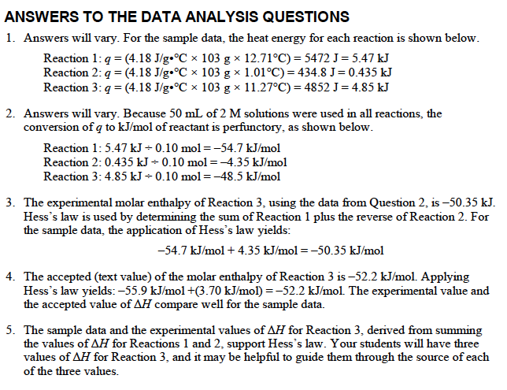and thought

