Week 7 Packet – Honors Chem

This is *hopefully* all the handouts we will use this week in Honors Chem. Due to the challenging logistics of this year, please offer grace if I miss a handout or if things change during the week. **Please note** – You do not *have* to print. I am just providing the option to make things easier for those who want to print. All of these pages are on the class website, always! [www.mychemistryclass.net](http://www.mychemistryclass.net)

**\*I will put the glue ins for the notes on the front and/or back of the packet cover page like this – since you don’t need the cover page for anything you can always just cut these out and glue them in. Trying to save some paper for those of you who are printing! ☺**

**N-14 N-14**

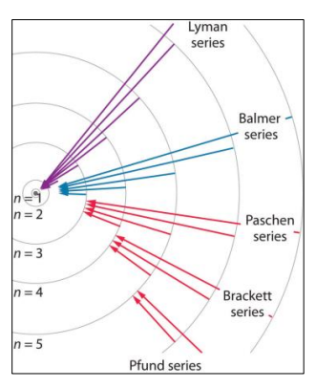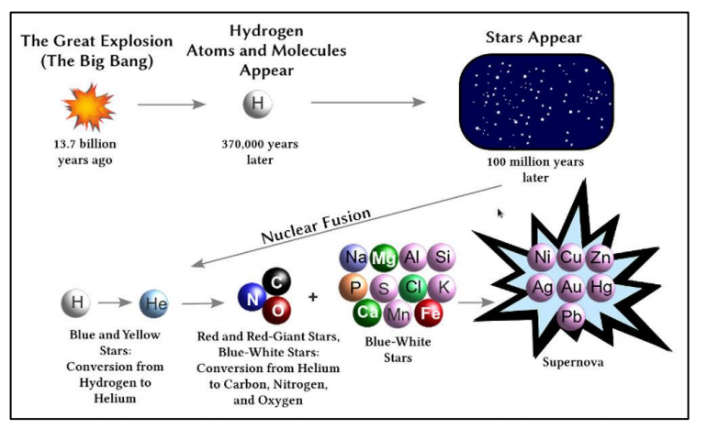

**N-13**