Week 4 Packet – Regular Chem

This is *hopefully* all the handouts we will use this week in Regular Chem. Due to the challenging logistics of this year, please offer grace if I miss a handout or if things change during the week. **Please note** – You do not *have* to print. I am just providing the option to make things easier for those who want to print. All of these pages are on the class website, always! [www.mychemistryclass.net](http://www.mychemistryclass.net)

**\*I will put the glue ins for the notes on the front and/or back of the packet cover page like this – since you don’t need the cover page for anything you can always just cut these out and glue them in. Trying to save some paper for those of you who are printing! ☺**

**Page 28**

**Page 27**

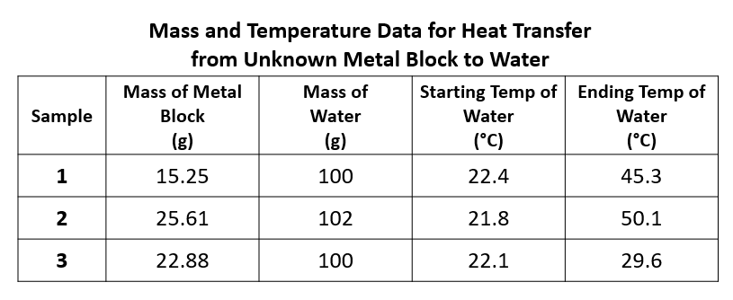

**Page 27**

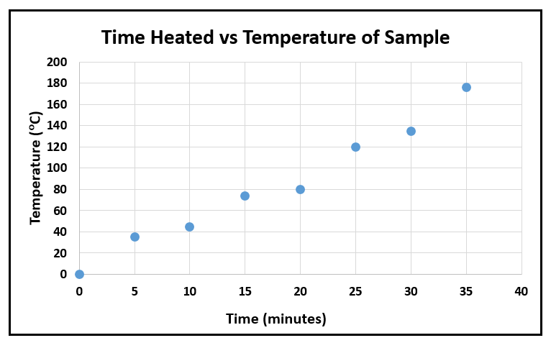

**Page 29**

|  |  |  |
| --- | --- | --- |
|  | **Convert to new unit** | |
| **#1** | **27500 mg 🡪 g** |
| **#2** | **0.15 DL 🡪 mL** |
| **Convert into Std. Form** | |
| **#3** | **1.0 x 101** |
| **#4** | **1.0 x 100** |
| **#5** | **1.0 x 10-1** |
| **#6** | **2.5 x 104** |
| **#7** | **3.8 x 10-2** |
| **Convert into Sci. Not.** | |
| **#8** | **541** |
| **#9** | **9.5** |
| **#10** | **0.025** |

CONVERTING AND   
SCIENTIFIC NOTATION

Show work on notebook paper!

**Convert:**

1. 1000mg 🡪 g **5)** 80 cm 🡪 m
2. 1L 🡪 mL **6)** 75 mL 🡪 L
3. 160cm 🡪 mm **7)** 5.6 m 🡪 cm
4. 1.4 km 🡪 m **8)** 65 g 🡪 mg

**Compare using < , > , or =**

1. 7g ? 698mg
2. 1,500 mL ? 1.5 L
3. 536 cm ? 53.6 dm
4. 3.6 m ? 36cm

**Write the abbreviation for each metric unit and tell if it measures mass, length, or volume**

1. decigram
2. milliliter
3. meter
4. decameter

Write in scientific notation:

1. 12
2. 0.156000
3. 0.00000000853

Write in standard notation:

1. 1.98 x 104
2. 4.5 x 10-6
3. 2.71 x 10-1

What is wrong with the following #s?

1. 0.54 x 105
2. 97 x 10-4

Why does this not make sense? Look at the number/exponent!

1. The diameter of a particular atom is 1.3 x 108 cm.

Solve the following word problems:

1. In Australia, the people use approximately 2,240,000,000 pounds of bread in a year. Put in scientific notation
2. 0.000065 is the wave length of yellow light. Put in scientific notation.
3. A proton weighs 1.673 x 10-27 kg, a neutron weighs 1.75 x 10-27 kg, and an electron weighs 9.11 x 10 -31 kg. Write the heaviest particle’s mass in standard notation. Make sure you don’t forget to look at the exponent in addition to the number itself!